

|  |
| --- |
| Close-up image showing the leaf-sides of two oversized books side-by-side on a bookshelf, with additional books in soft focus background |
| Students’ Grade Monitoring System  SGM |
| |  |  |  | | --- | --- | --- | | Rasika Weragoda |  | GAM/2015/HNDIT/0023 | |

**TITLE PAGE**

**Students’ Grade Monitoring System**

**W.D Rasika**

**GAM/2015/HNDIT/0023**

Project report submitted to the Department of Information Technology,

Advanced Technological Institute (Name of your institute) - Sri Lanka

For the partial fulfillment of the requirements of the

Higher National Diploma in Information Technology

**March 11 2017**

**Declaration**

I declare that this report is my own work and has not been submitted in any form for another degree or diploma at any university or other institution of tertiary education. Information derived from the published or unpublished work of others has been acknowledged in the text and a list of references is given.

Name of the Student ………………………………………

Signature of the Student

Date:

Supervised by ……………………………………...

Name of Supervisor: Signature of Supervisor

**Acknowledgments**

I have taken efforts in this project. However, it would not have been possible without the kind support and help of many individuals and organizations. I would like to extend my sincere thanks to all of them.

I am highly indebted to dear HNDIT Teachers for their guidance and constant supervision as well as for providing necessary information regarding the project & also for their support in completing the project. I would like to express my gratitude towards my parents & member of HNDIT for their kind co-operation and encouragement which help me in completion of this project. I would like to express my special gratitude and thanks to industry persons for giving me such attention and time. My thanks and appreciations also go to my colleague in developing the project and people who have willingly helped me out with their abilities.

Furthermore I would also like to acknowledge with much appreciation the crucial role of the staff of B.M. Terrence Chandike, who gave the permission to use all required equipment and the necessary materials to complete the task “SGM”. A special thanks goes to Arosh Dissanayake, who help me to assemble the parts and gave suggestion about the task “SGM.

**Abstract**

A Student Grade Monitoring system (SGM) can be used to track the progression of students. This project is to implement a Students’ Grade Monitoring System with Advanced analyzing graphs. This system is for school children from grade 6-11.

Tracking the marks of students, analyzing students' progression, and analyzing performance variation over the years in school are the main functionalities of this system.

A lot of graphs are added with the system and user can select two parties to compare. Teachers and students are the target users of this system.

And instead adding single student’s subjects marks, teacher can upload CSV file with student’s marks. So it is very efficient way to adding data to the database.

**Table of Contents**

**Declaration ii**

**Acknowledgments iii**

**Abstract iv**

**Table of Contents v**

**CHAPTER 01**

**1.1INTRODUCTION 1**

**1.2 RELATED WORK**

**1.2.1 PowerSchool 2**

**1.2.2 KIOSK 2**

**1.2.3 QuickSchools 2**

**1.3 OBJECTIVES AND SCOPE**

**1.3.1 Scope 3**

**1.3.2 Objectives 3**

**1.4 TECHNOLOGIES, TOOLS AND HARDWARE COMPONENT**

**1.4.1 Technology 4**

**1.4.2 Tools 4**

**1.4.3 Hardware Component 4**

**CHAPTER 02**

**SYSTEM ANALYSIS.**

**2.1 FUNCTIONAL REQUIREMENT 5**

**2.2 NON FUNCTIONAL REQUIREMENTS 6**

**2.3 HARDWARE REQUIREMENTS 6**

**2.4 SOFTWARE REQUIREMENTS 6**

**CHAPTER 03**

**SYSTEM DESIGN. 7**

**3.1 OVERVIEW OF METHODOLOGY 7**

**3.2 CSV FILE**

**3.2.1 Advantages of CSV files 8**

**3.2.2 Format of project CSV file 8**

**3.3 USE CASE 9**

**3.4 USE CASE DESCRIPTION 10**

**3.5 ACTIVITY DIAGRAM**

**3.5.1 System activity Diagrams 15**

**3.5.2 Activity Diagrams for sub component 16**

**3.6 CLASS DIAGRAM 20**

**3.7 DATABASE**

**3.7.1 Entity Relation Diagram (ER) 21**

**3.7.2 Database structure 22**

**3.7 INTERFACES 26**

**CHAPTER 04**

**IMPLEMENTATION 30**

**4.1 SOURCE CODES 30**

**4.2 ACHIEVEMENTS**

**4.2.1 WHAT WE HAVE DONE 63**

**4.2.2 ADDITIONAL ENHANSMENTS 63**

**CHAPTER 5**

**CONCLUSION 63**

**REFERENCES 6**

**CHAPTER 01**

**INTRODUCTION**

**1.1 INTRODUCTION**

Students’ Grade Monitoring System makes recording and calculating grades simple and efficient. Simply enter students’ grades and let SGM to do the rest analyzing. Teachers no longer have to spend hours over grade books, papers, reports, and calculators. SGM does all of the calculations and give the analyzed graphs.

So teachers can monitor grades and be an active participant in each and every student’s progression.

There is a huge issue in monitoring the progress of students in school. There are already a lot of tools/systems that keep student details and grades/marks. But the main issue in the current set up is there is no tool to analyze student progression and see how his/her performance varies over the years in school. So this system is designed due to following requirements.

* Neediness to monitor students *individually*.
* To *compare* students’ marks with their own *previous* grades.
* Need to track weak students and *turning point* of them.
* Compare average marks of student with *class average*.
* View *all grades* for all subjects that he learnt.

So, this system is developed to

i. Track students’ marks and

ii. Display the analyzed marks in various graphs which are fully customizable.(So that analyzing the student’s progression is easy…)

**1.2 RELATED WORK**

There are already a lot of applications which can keep students’ details and the records of grades. But the issue is there is no tool to analyze the grades and take decisions/predictions about the students’ progression.

**1.2.1 PowerSchool**

PowerSchool empowers teachers and administrators to use real-time data insights and analysis to adjust instruction from the student to the school level. This system helps teachers to see where a student’s strengths and weaknesses lie. PowerSchool helps students to understand their own learning. It shows their progress, gives real-time feedback and scores, and fosters engagement in learning through content and assignments. Then parents have a benefit from transparency of their child’s assignments, scores, and grades, getting real-time insight into their child’s learning, growth, and weaknesses.

**1.2.2 KIOSK**–Student’s grade monitoring system [2]

KIOSK is a module that can be easily provide the grades of the students even the faculty members are not present in the community. It only calculate the general average of the student and allow to view the previous grades also.

**1.2.3 QuickSchools –GradeBook***[3]*

QuickSchools Gradebook feature makes recording and calculating grades simple and efficient. Simply enter student grades and let QuickSchools do the rest. Fully customizable, you can weight individual assignments or categories to suit your class’s needs, add and delete assignments, and redefine assignments and grade weighting. After new grades are entered, the overall class grade is averaged and updated.

These all applications record grades and information of students and give access to teachers and students (sometimes parents) to view previous and current grades. And also give the general average of the marks. There is no way to compare two students or to compare a student with his/her own previous grades.

The SGM system can display that processed marks by advanced analysis graphs.

**1.3 OBJECTIVES AND SCOPE**

**1.3.1 Scope**

The scope of this system is limited to students and teachers. Because of only teachers and students are allowed to access the system. And only the students in grade 6 to 11 are targeted. And also there is limited number of choices for graphs in dashboard.

**1.3.2 Objectives**

The main objective of this student grade monitoring system is to track the marks of each student and analyze those marks in a meaningful way. The way we used to analyze the marks is following.

1. Track the student’s progression for each subject
2. Track the average of student when he/she in different grades
3. Track his/her marks for mathematics
4. Compare the specify student with the marks of best student in the class
5. Track his position in the class in different grades
6. Average marks for all subjects

Teachers can see the progression of each student individually and overall in parents meetings or other special occasions. Using these analyzed graphs teacher or parents can study whether there is a turning point or not. So teachers can keep touch in weak students like that.

* 1. **TECHNOLOGIES ,TOOLS AND HARDWARE COMPONENT**

**1.4.1 Technology**

* **Change Theme**
  + Bootstrap framework
* **Connect Database**
  + Mysql
  + Php
* **Graph design**
* Highcharts

**1.4.2 Tools**

* **Integrate Development Environment(IDE)**
  + Phpstrom
  + Eclipse
  + codeIgniter framework
* **Database Environment**
  + MySql (Workbench)
  + WampServer
    1. **Hardware Component**
* USB Flash Drive

**CHAPTER 02**

**SYSTEM ANALYSIS.**

* 1. **FUNCTIONAL REQUIREMENT**
* Authentication : To protect privacy of information
* Displaying student information
* Flexibility of user interface
* Faster processing
* View of previous data
* Display statistical report of a student
* Enable to compare with friends
* Displaying analyzing graphical charts
* Edit user profile
* Sessions
* Generating graphical reports
  1. **NON FUNCTIONAL REQUIREMENTS**
* Reliability is the ability of a system to perform its required functions under stated conditions for a specific period of time.
* Performance requirements concern the speed of operation of a system.
* Security Unauthorized access to the system and its data is not allowed.
* User Friendly is the ease with which a user can learn to operate, prepare inputs for, and interpret outputs of system or component.
* Modifiability Requirements about the effort required to make changes in the software
* Default username and password submitted for student
  1. **HARDWARE REQUIREMENTS**
* Processor : Pentium 4 @ 2.40 GHZ or Higher
* RAM : 1GB
* Hard disk : 80 GB
* Monitor : 14” CRT Or LED
* Keyboard : Normal or Multimedia
* Mouse : Compatible mouse
* USB Flash Drive
* Printer
  1. **SOFTWARE REQUIREMENTS**
* MY SQL Server 5.5
* .NET Framework 3.5
* Operating system : windows XP, windows 7, windows 8

**CHAPTER 03**

**SYSTEM DESIGN.**

**3.1 OVERVIEW OF METHODOLOGY**

The implementation of this system has done as follows.

Initially requirements were gathered and milestones were planned.

Then, the database was designed as follows. **MYSQL** is chosen to create the database schema and to handle the database.

There are ten tables in this database system. It contains student, student users, classes, students with their class, teacher users, teachers, subjects, teachers with their subjects, marks.

**CSV** (comma separated value) files were created to insert data to database. Those csv files were uploaded to the database using **PHP**.

**PHP** would be the main programming language for the development of this system. PHP is a server-side language. PHP was chosen because it is a familiar language to us.

Then, Codeigniter (CI) was selected as the PHP framework. **Codeigniter** is an open-source PHP web application framework. It is a Model-View-Controller framework. Data was retrieved from database and put them in to JSON format. All graphs in this system are drawn using **High Charts**. HighCharts uses JSON format in adat. In HighCharts JQueryand **JavaScript** is used.

Finally web application was designed using CSS (Bootstrap). . **AJAX** was also a big help in developing the system. It would make the system more interactive without too many refresh when connecting to the server. The method involved is to be able to effortlessly update a section of Web application.



**3.2 CSV FILE**

CSV (Comma Separated Values) is a file format for data storage which looks like a text file. The information is organized with one record on each line and each field is separated by comma. The file can be managed via Microsoft Excel (or similar programs) and lists the merchant’s products, codes, image links, etc. The fields provided by default include path, id, name, code, price, headline and many others

**3.2.1 Advantages of CSV files**

* CSV is human readable and easy to edit manually
* CSV is simple to implement and parse
* CSV is processed by almost all existing applications
* CSV provides a straightforward information schema
* CSV is faster to handle
* CSV is smaller in size
* CSV is considered to be standard format

**3.2.2 Format of project CSV file**

* Marks for each value subject CSV file format

**Student_index, subject_marks, term**

* Student list CSV file format

**Student_index, first_name, Last_name, Address, telephone**

* 1. **USE CASE**

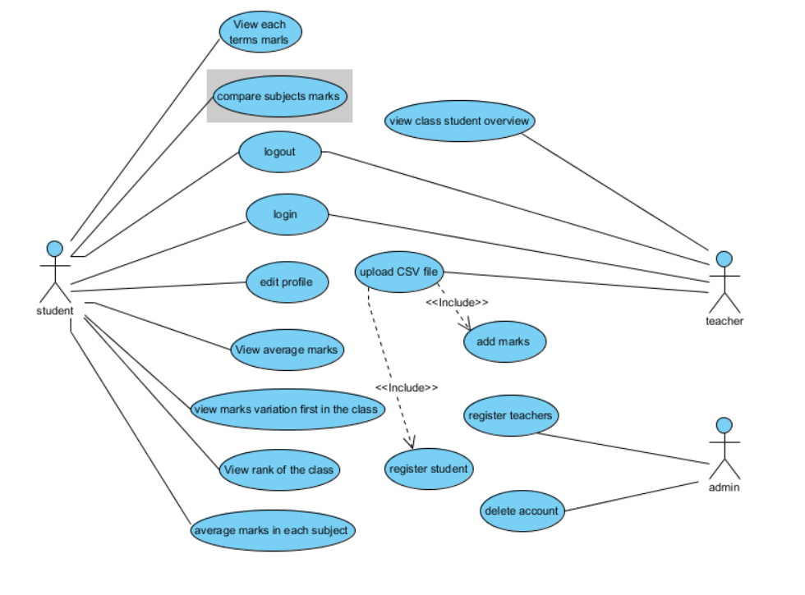

* 1. **USE CASE DESCRIPTION**

**Login**

1. Title :-login
2. Purpose/overview :-

* Students able to see their grades
* Teachers get to know their student
* Upload marks

1. Actor:-

Student, Teachers

1. Pre-Condition:-

* Teacher create student account
* Admin creates a student account

1. Post Condition:-
2. Normal flow of event :-

* Student/Teacher login their username and password

**View Rank of the class**

1. Title :-view Rank of the class
2. Purpose/overview :-

Student can measure their class rank

1. Actor:-

Student

1. Pre-Condition:-

Teacher create student account

1. Post Condition:-

If student marks is available.

1. Normal flow of event :-

* Student login their username and password
* Atomatically generate graph of their rank in the class

**View each term subjects marks**

1. Title :-View each term subjects marks
2. Purpose/overview :-

Students able to see their each subjects marks in each term

1. Actor:-

Student

1. Pre-Condition:-

Teacher create student account

1. Post Condition:-

If student marks is available.

1. Normal flow of event :-

* Student login their username and password
* Atomatically generate graph of their each term marks

**View Average marks of the student with class average**

1. Title :-Average marks of the student with class average
2. Purpose/overview :-

Students able to see their position in the class

1. Actor:-

Student

1. Pre-Condition:-

Teacher create student account

1. Post Condition:-

If student marks is available.

1. Normal flow of event :-

* Student login their username and password
* Automatically generate graph of their marks compare to class average

**View marks variation first in the class**

1. Title :-View marks variation first in the class
2. Purpose/overview :-

Students able to compare with the top of the class

1. Actor:-

Student

1. Pre-Condition:-

Teacher create student account

1. Post Condition:-

If student marks is available.

1. Normal flow of event :-

* Student login their username and password
* Automatically generate graph of their marks compare to top of the class

**View Average marks of each subject**

1. Title :-view average marks of each subjects
2. Purpose/overview :-

Students able to see their position in the class

1. Actor:-

Student

1. Pre-Condition:-

Teacher create student account

1. Post Condition:-

If student marks is available.

1. Normal flow of event :-

* Student login their username and password
* Automatically generate graph of their marks each subject

**Edit student profile**

1. Title :-Edit student profile
2. Purpose/overview :-

Students able to assign any username or password, they want instead of the default password

1. Actor:-

Student

1. Pre-Condition:-

Teacher create student account with default password

1. Post Condition:-

If student marks is available.

1. Normal flow of event :-

* Student login their username and password
* Edit their profile

**Compare marks with their class mates**

1. Title :-compare with their class mates
2. Purpose/overview :-

Students able to compare subject result with their friends

1. Actor:-

Student

1. Pre-Condition:-

Teacher create student account

1. Post Condition:-

If student marks is available.

1. Normal flow of event :-

* Student login their username and password
* Assign their friends name
* Automatically generate graph of their marks with assigned friend

**View student overview**

1. Title :-View student overview
2. Purpose/overview :-

Teachers able to see class student’s grades

1. Actor:-

Teacher

1. Pre-Condition:-

Admin create teacher account

1. Post Condition:-
2. Normal flow of event :-

* Teacher login their username and password
* Assign student need to be search
* Automatically generate graph of selected student

**Upload CSV file**

1. Title :-upload CSV file
2. Purpose/overview :-

Provide database to student’s marks

1. Actor:-

Student

1. Pre-Condition:-

Admin create teacher account

1. Post Condition:-

If student marks is available.

1. Normal flow of event :-

* Teacher login their username and password
* Upload CSV file to the system
  1. **ACTIVITY DIAGRAM**

**3.5.1 System activity Diagrams**

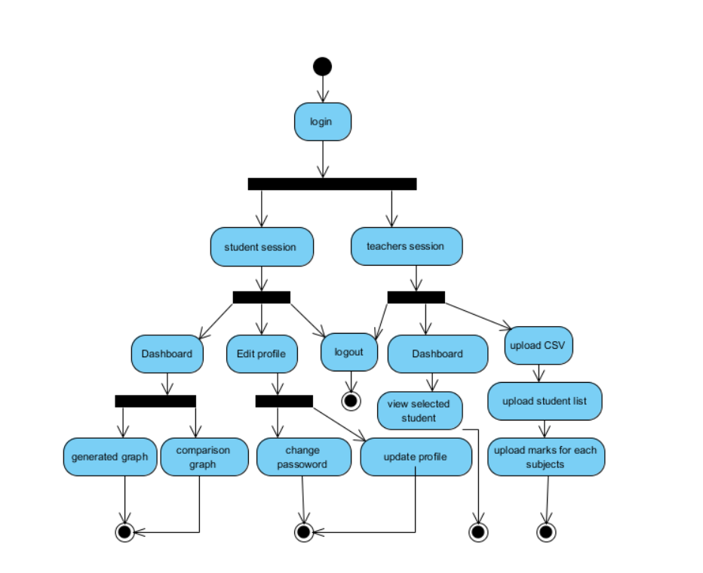

**3.5.2 Activity Diagrams for sub component**

**Activity Diagram for login use case**

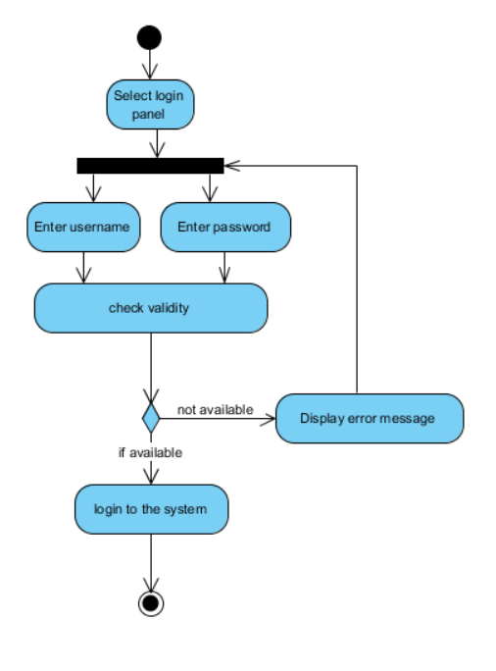

**Activity Diagram for edit profile use case**

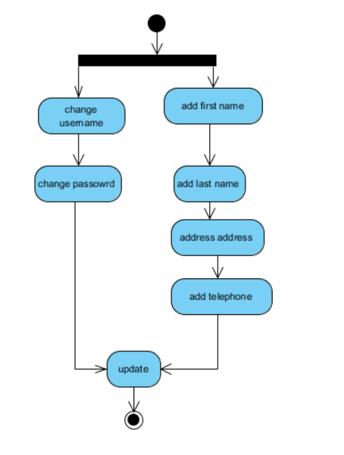

**Activity Diagram for upload CSV file use case**

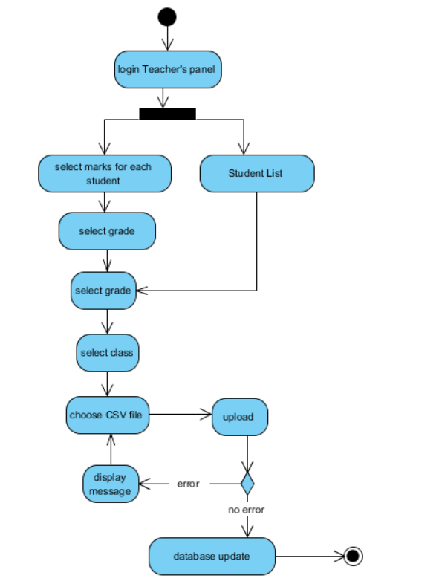

**Activity Diagram for compare marks use case**

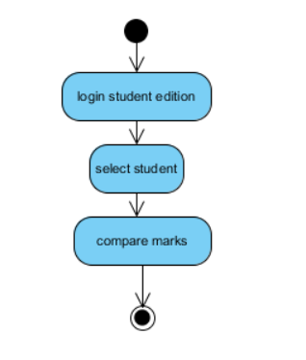

* 1. **CLASS DIAGRAM**

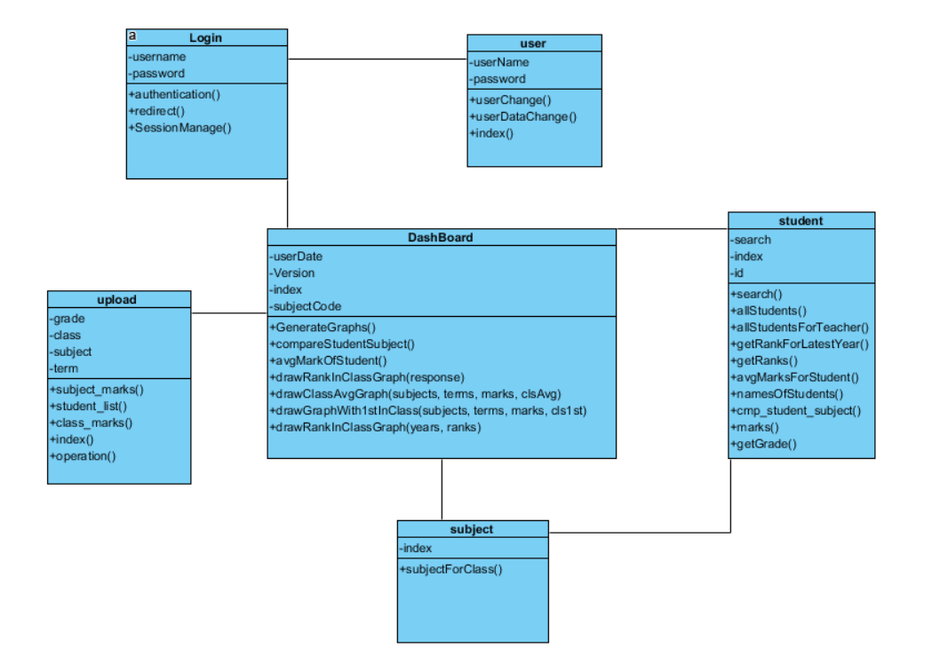

* 1. **DATABASE**
     1. **Entity Relation Diagram (ER)**

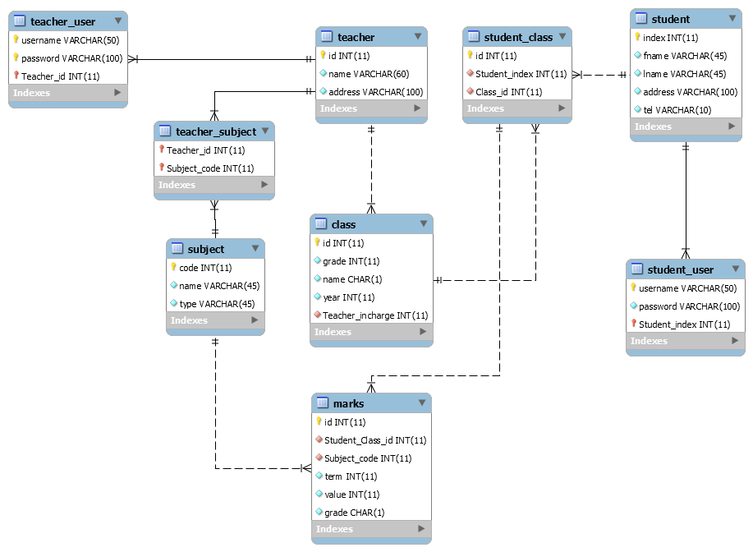

* + 1. **Database structure**

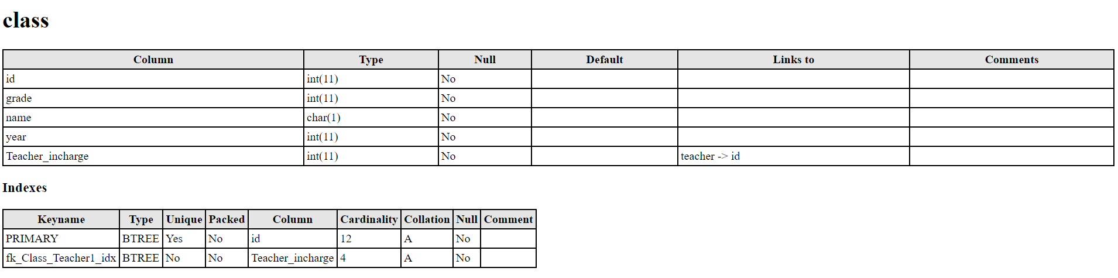

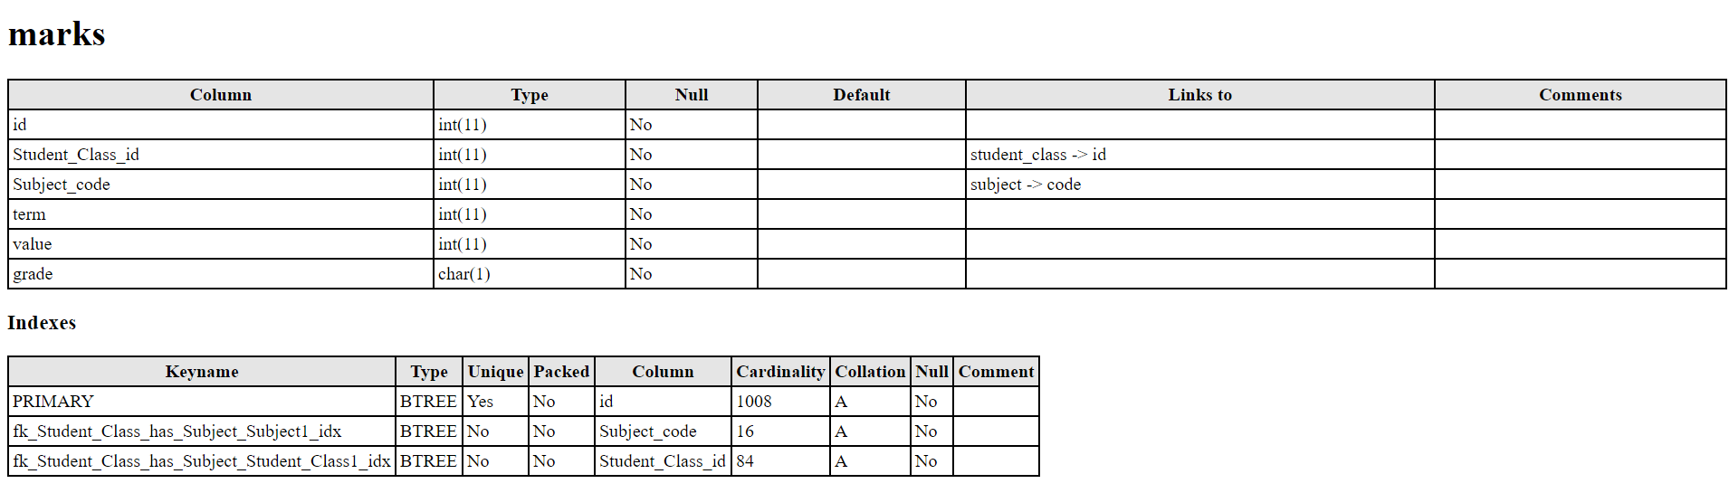

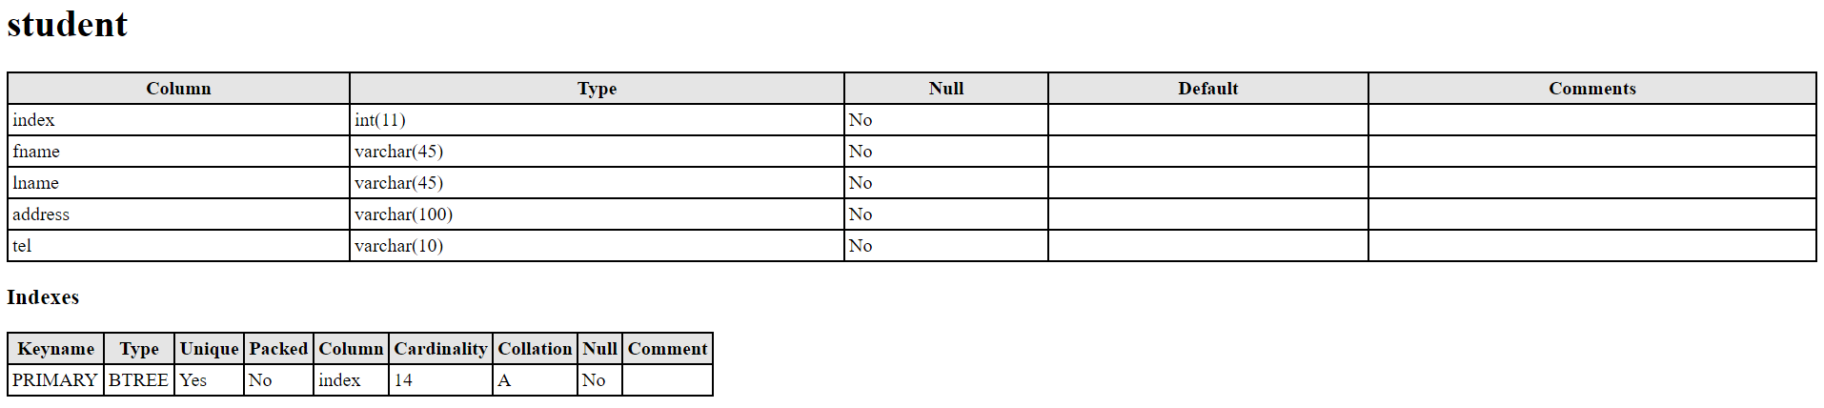

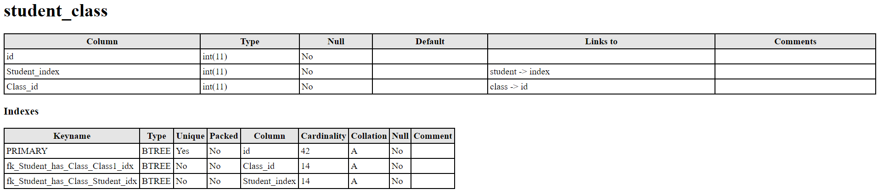

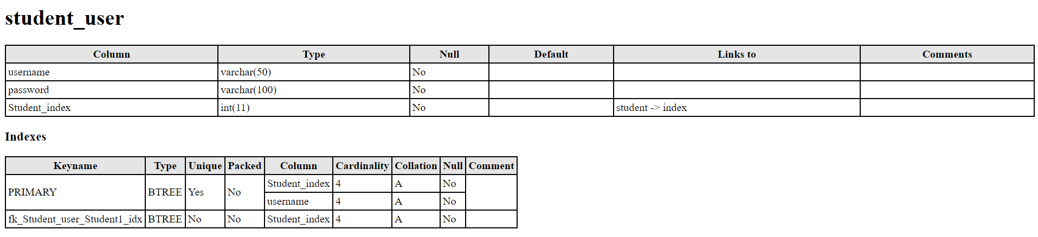

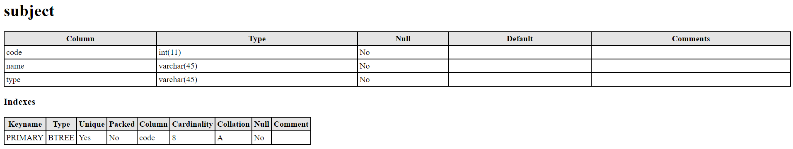

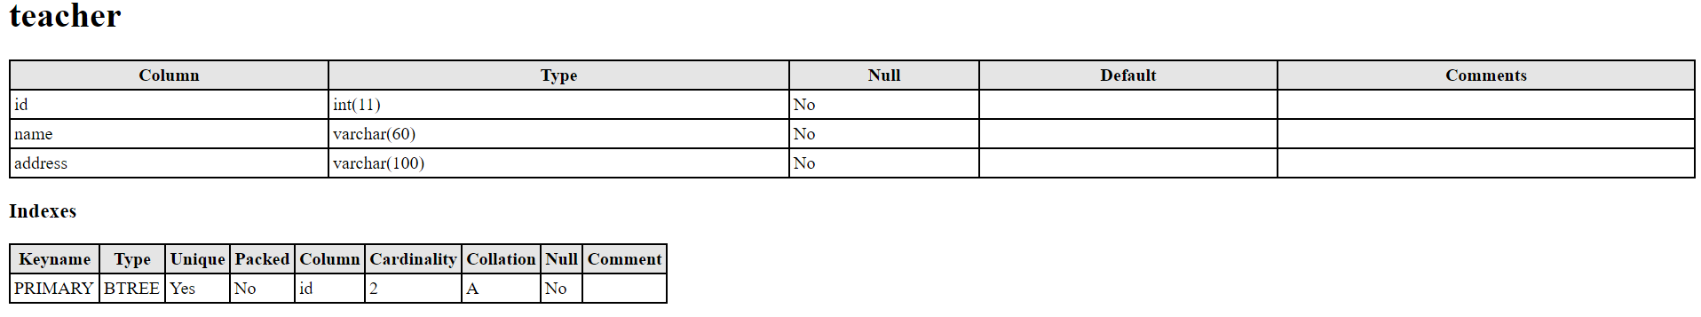

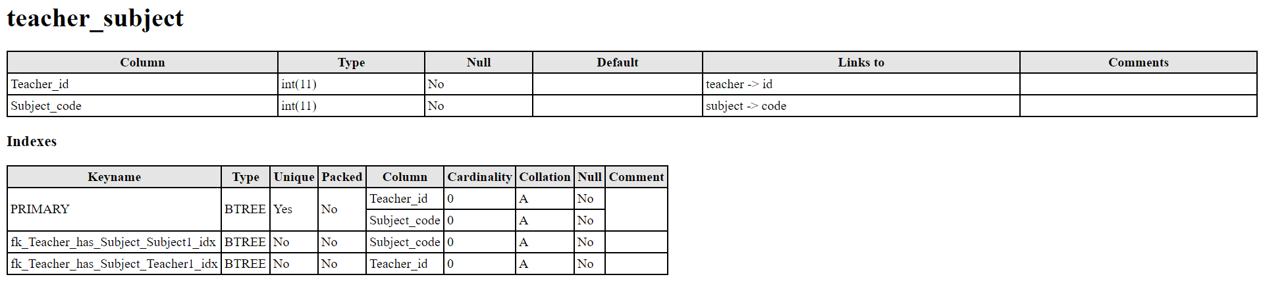

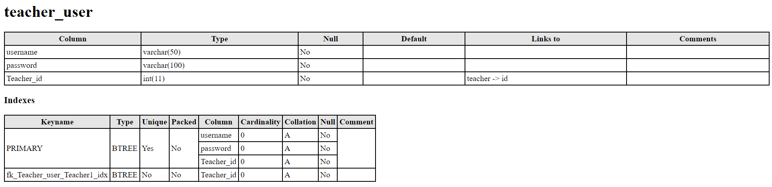

* 1. **INTERFACES**

Student login

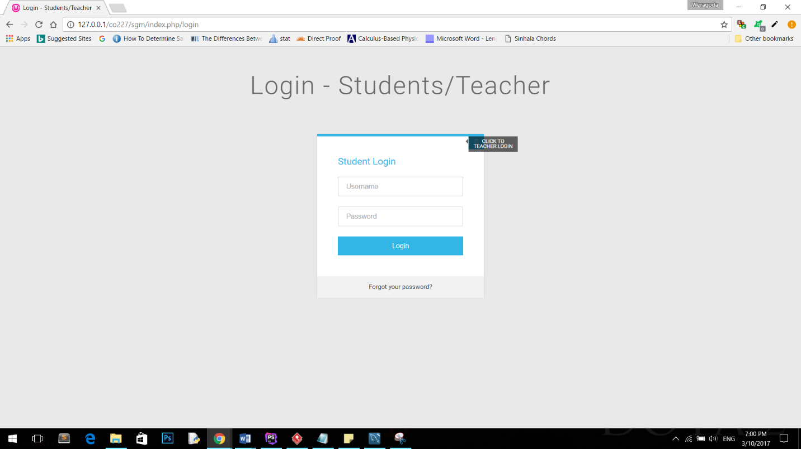

Student Dashboard

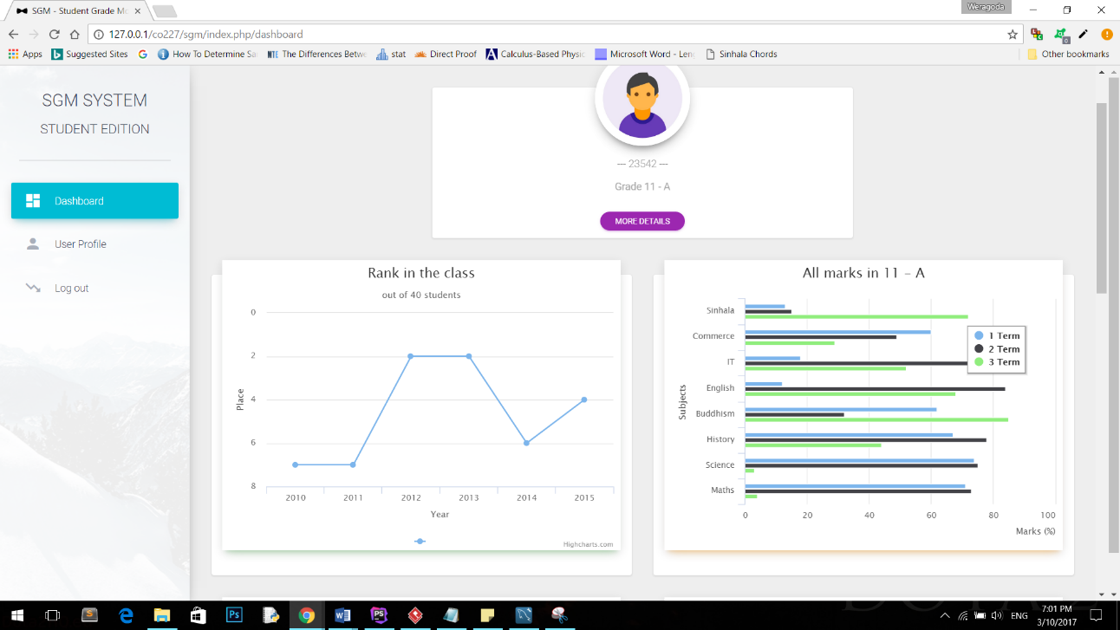

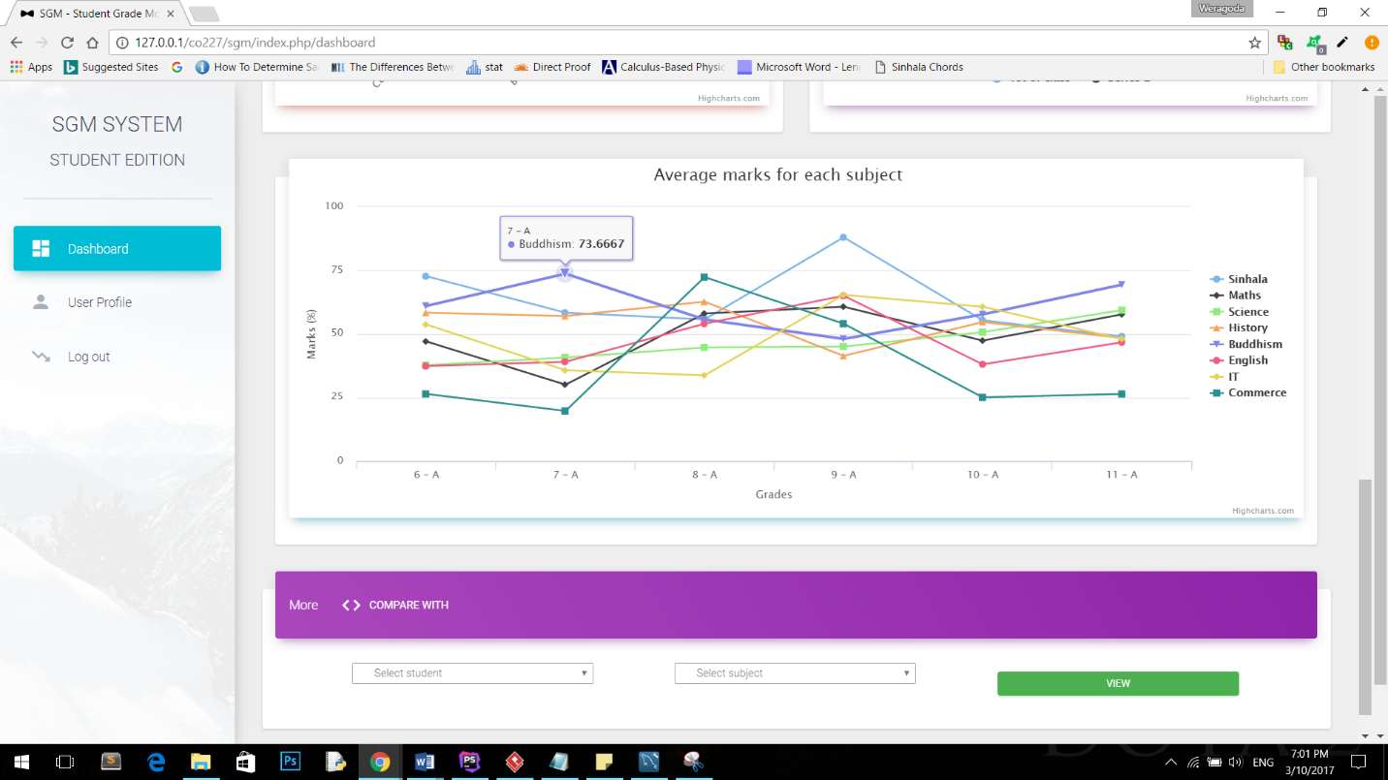

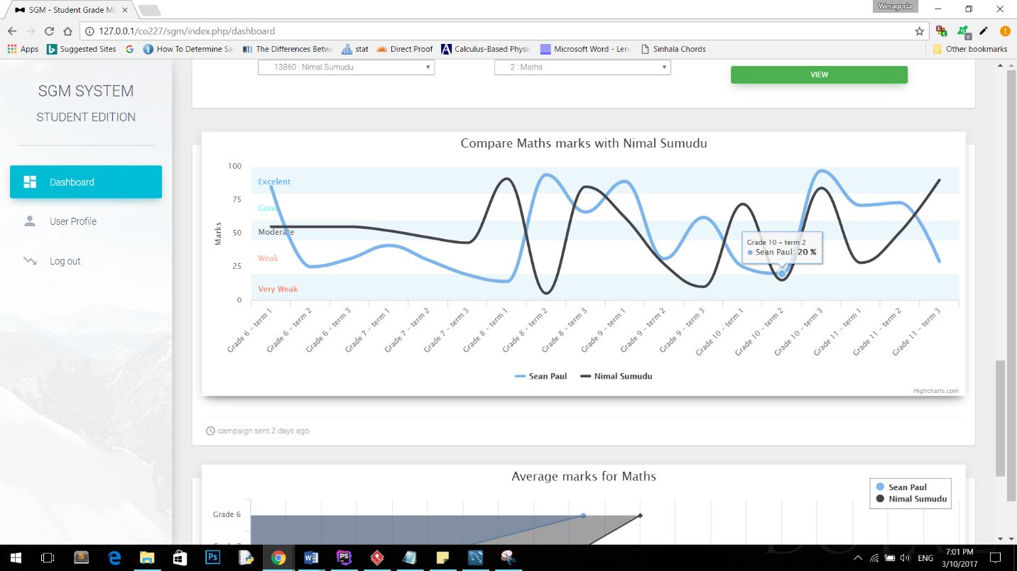

Edit profile Interface

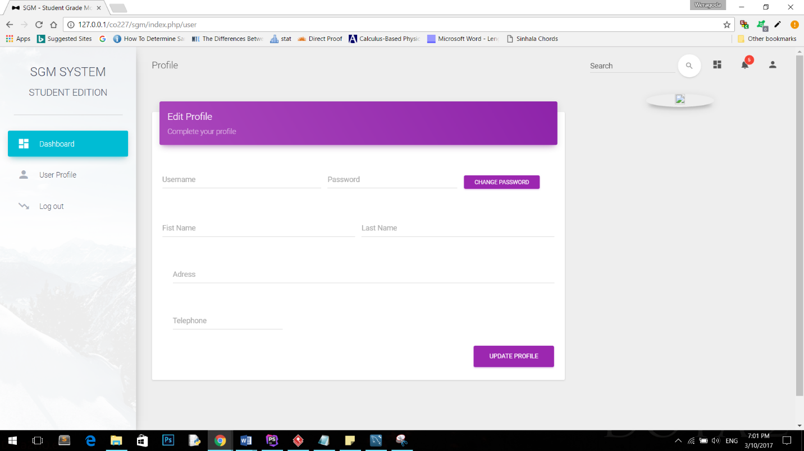

Teacher’s Login

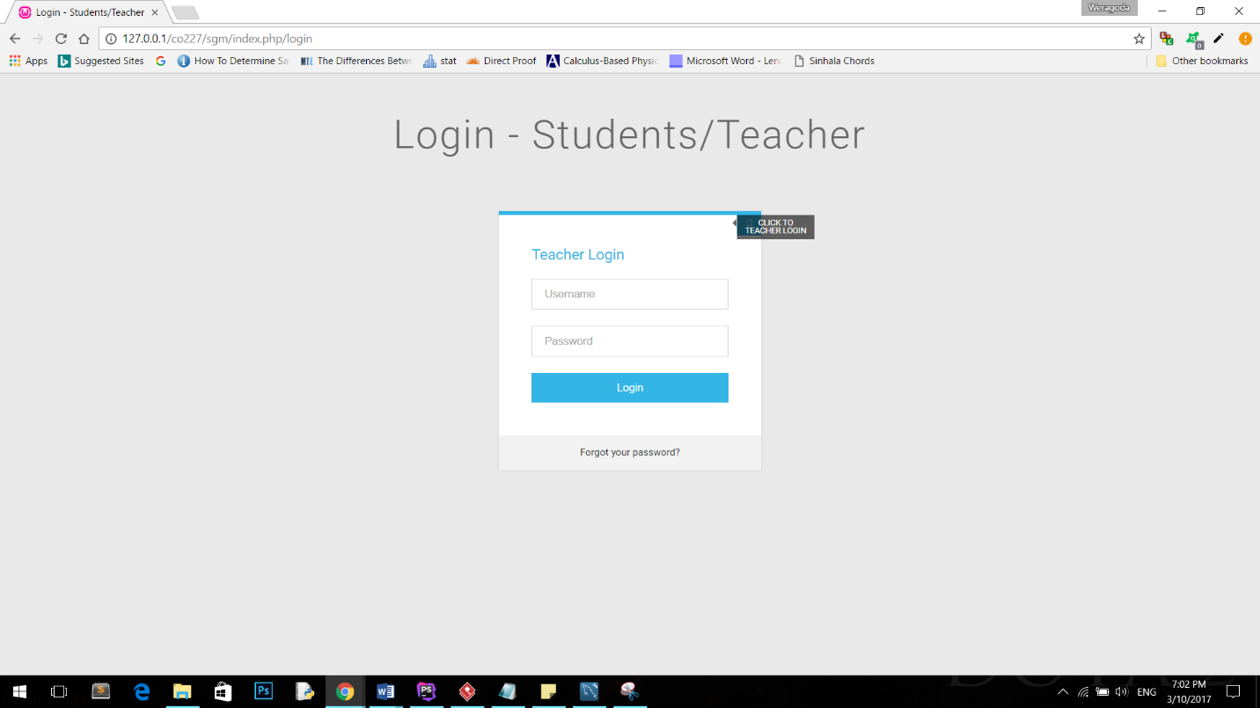

CSV upload Interface

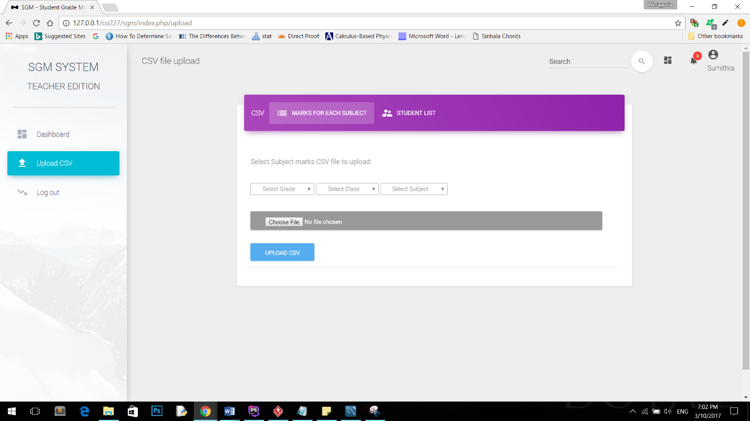

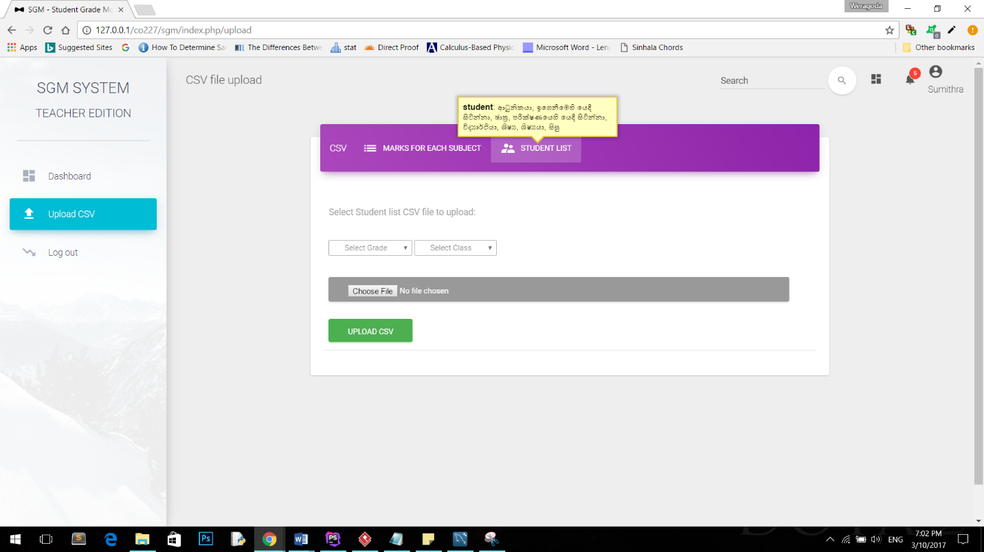

**CHAPTER 04**

**IMPLEMENTATION**

To implement I used codeIgnater. CodeIgniter is based on the Model-View-Controller (MVC) development pattern. MVC is a software approach that separates application logic from presentation. In practice, it permits your web pages to contain minimal scripting since the presentation is separate from the PHP scripting.

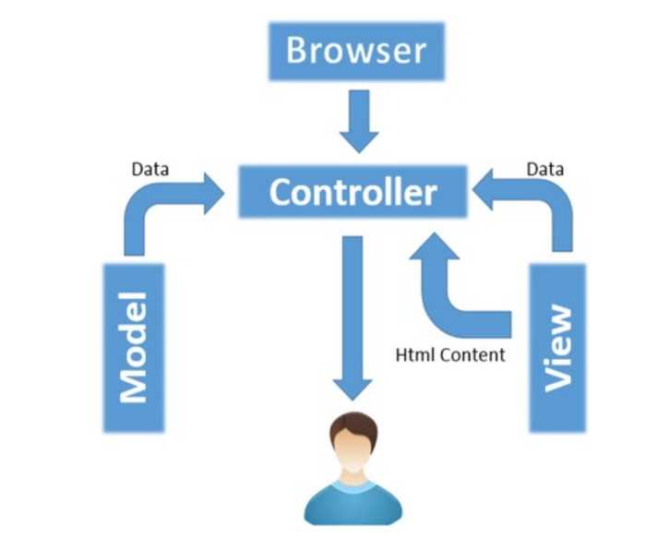

**4.1 SOURCE CODES**

**Views**

* ***Login.php***

<!DOCTYPE **html**>  
<**html**>  
<**head**>  
 <**meta charset="UTF-8"**>  
 <**title**>Login - Students/Teacher</**title**>  
  
 <**link rel="stylesheet" href="<?php echo** base_url() **?>assets/css/reset.min.css"**>  
  
  *<!-- Fonts and icons -->* <**link href="<?php echo** base_url() **?>assets/css/font-awesome.min.css" rel="stylesheet"**>  
 <**link href='<?php echo** base_url() **?>assets/css/google_fonts.css' rel='stylesheet' type='text/css'**>  
  
 <**script src="<?php echo** base_url() **?>assets/js/jquery-3.1.0.min.js"**></**script**>  
 <**script src="<?php echo** base_url() **?>assets/js/jquery-ui.min.js"**></**script**>  
  
  
 <**link rel="stylesheet" href="<?php echo** base_url() **?>assets/css/loginstyle.css"**>  
  
  
</**head**>  
  
<**body**>  
<**div class="pen-title"**>  
 <**h1**>Login - Students/Teacher</**h1**>  
  
 **<?php  
 if**($this->**session**->flashdata(**'error'**)){  
 $msg = $this->**session**->flashdata(**'msg'**);  
 **echo "<h5 style=\"color: red\">**$msg**</h5>"**;  
 }  
 **?>**</**div**>  
*<!-- Form Module-->*<**div class="module form-module"**>  
 <**div class="toggle"**><**i class="fa fa-times fa-pencil"**></**i**>  
 <**div class="tooltip"**>Click To Teacher Login</**div**>  
 </**div**>  
  
  
  
 <**div class="form"**>  
 <**h2**>Student Login</**h2**>  
 <**form method="post" action="<?=** site_url(**'login/student'**)**?>"**>  
 <**input name="username" type="text" placeholder="Username"**/>  
 <**input name="password" type="password" placeholder="Password"**/>  
 <**button**>Login</**button**>  
 </**form**>  
 </**div**>  
 <**div class="form"**>  
 <**h2**>Teacher Login</**h2**>  
 <**form method="post" action="<?=** site_url(**'login/teacher'**)**?>"**>  
 <**input name="username" type="text" placeholder="Username"**/>  
 <**input name="password" type="password" placeholder="Password"**/>  
 <**button**>Login</**button**>  
 </**form**>  
  
 </**div**>  
 <**div class="cta"**><**a href="#"**>Forgot your password?</**a**></**div**>  
</**div**>  
<**script type="text/javascript"**>  
 **$**(**'.toggle'**).click(**function** () {  
 *// Switches the Icon* **$**(**this**).**children**(**'i'**).**toggleClass**(**'fa-pencil'**);  
 *// Switches the forms* **$**(**'.form'**).**animate**({  
 **height**: **"toggle"**,  
 **'padding-top'**: **'toggle'**,  
 **'padding-bottom'**: **'toggle'**,  
 **opacity**: **"toggle"** }, **"slow"**);  
 });  
</**script**>  
  
</**body**>  
</**html**>

* ***DashBoard student php***

<**div class="main-panel"**>  
 <**nav class="navbar navbar-transparent navbar-absolute"**>  
 <**div class="container-fluid"**>  
 <**div class="navbar-header"**>  
 <**button type="button" class="navbar-toggle" data-toggle="collapse"**>  
 <**span class="sr-only"**>Toggle navigation</**span**>  
 <**span class="icon-bar"**></**span**>  
 <**span class="icon-bar"**></**span**>  
 <**span class="icon-bar"**></**span**>  
 </**button**>  
 <**a class="navbar-brand" href="#"**>Student Overview</**a**>  
 </**div**>  
 <**div class="collapse navbar-collapse"**>  
 <**ul class="nav navbar-nav navbar-right"**>  
 <**li**>  
 <**a href="#pablo" class="dropdown-toggle" data-toggle="dropdown"**>  
 <**i class="material-icons"**>dashboard</**i**>  
 <**p class="hidden-lg hidden-md"**>Dashboard</**p**>  
 </**a**>  
 </**li**>  
 <**li class="dropdown"**>  
 <**a href="#" class="dropdown-toggle" data-toggle="dropdown"**>  
 <**i class="material-icons"**>notifications</**i**>  
 <**span class="notification"**>5</**span**>  
 <**p class="hidden-lg hidden-md"**>Notifications</**p**>  
 </**a**>  
 <**ul class="dropdown-menu"**>  
 <**li**><**a href="#"**>Mike John responded to your email</**a**></**li**>  
 <**li**><**a href="#"**>You have 5 new tasks</**a**></**li**>  
 <**li**><**a href="#"**>You're now friend with Andrew</**a**></**li**>  
 <**li**><**a href="#"**>Another Notification</**a**></**li**>  
 <**li**><**a href="#"**>Another One</**a**></**li**>  
 </**ul**>  
 </**li**>  
 <**li**>  
 *<!-- site_url('user')* **?>**<**i class="material-icons"**>account_circle</**i**>  
 **<?php  
 if** ($this->**session**->userdata(**'logged'**)) {  
 $user = $this->**session**->userdata(**'user'**);  
 **if** ($this->**session**->userdata(**'version'**) == **'Student'**) {  
 $username = $user[0][**'fname'**] . **' '** . $user[0][**'lname'**];  
 } **else** {  
 $username = $user[0][**'name'**];  
 }  
 **echo "<p class=''>**$username**</p>"**;  
 }  
  
  
 **?>** </**li**>  
 </**ul**>  
 *<!-- -->***<?php** *//if($this->session->userdata('version') == 'Student'){echo 'pointer-events:none;';}***?>** <**form class="navbar-form navbar-right" role="search"**>  
 <**div class="form-group is-empty dropdown" style=""**>  
 <**input type="text" class="form-control dropdown-toggle" id="search" data-toggle="dropdown"  
 placeholder="Search" <?php if** ($this->**session**->userdata(**'version'**) == **'Student'**) {  
 **echo 'disabled'**;  
 } **?>**>  
 <**span class="material-input"**></**span**>  
 <**div class="card-content"**>  
 <**ul id="finalResults" class="dropdown-menu"**></**ul**>  
 </**div**>  
 </**div**>  
  
 <**button type="submit"  
 class="btn btn-white btn-round btn-just-icon" <?php if** ($this->**session**->userdata(**'version'**) == **'Student'**) {  
 **echo 'disabled'**;  
 } **?>**>  
 <**i class="material-icons"**>search</**i**>  
  
 </**button**>  
  
  
 </**form**>  
 </**div**>  
 </**div**>  
 </**nav**>  
  
 <**div class="content"**>  
  
  
 <**div class="container-fluid"**>  
 <**div**>  
 </**div**>  
 <**div class="row"**>  
 <**div class="col-md-3"**></**div**>  
 <**div class="col-md-6"**>  
 <**div class="card card-profile" style="display**: **none**;**" id="profile"**>  
 <**div class="card-avatar"**>  
 <**a href="#pablo"**>  
 <**img class="img" id="proPic" src=""**/>  
 </**a**>  
 </**div**>  
  
 <**div class="content"**>  
  
  
 <**h4 class="card-title" id="studentName"**></**h4**>  
 <**h6 class="category text-gray" id="indexNo"**></**h6**>  
 <**p class=""**>  
 <**label id="gradeLable"**></**label**>  
 </**p**>  
  
 <**a href="#pablo" class="btn btn-sm btn-primary btn-round"**>More Details</**a**>  
 </**div**>  
 </**div**>  
 </**div**>  
 <**div class="col-md-3"**></**div**>  
  
 </**div**>  
  
 <**div class="row"**>  
 <**div class="col-md-6"**>  
 <**div class="card"**>  
 <**div class="card-header card-chart" data-background-color="green"**>  
 <**div id="rank_in_class"**></**div**>  
 </**div**>  
 <**div class="card-content"**>  
 <**h4 class="title"**></**h4**>  
 </**div**>  
 </**div**>  
 </**div**>  
  
 <**div class="col-md-6"**>  
 <**div class="card"**>  
 <**div class="card-header card-chart" data-background-color="orange"**>  
 <**div id="allmarkschart"**></**div**>  
 </**div**>  
 <**div class="card-content"**>  
 <**h4 class="title"**></**h4**>  
 <**p class="category"**></**p**>  
 </**div**>  
 </**div**>  
 </**div**>  
  
  
 <**div class="col-md-6"**>  
 <**div class="card"**>  
 <**div class="card-header card-chart" data-background-color="red"**>  
 <**div id="classavgchart"**></**div**>  
 </**div**>  
 <**div class="card-content"**>  
 </**div**>  
 </**div**>  
 <**div class="col-md-6"**>  
 <**div class="card"**>  
 <**div class="card-header card-chart" data-background-color="purple"**>  
 <**div id="cmpfirstchart"**></**div**>  
 </**div**>  
 <**div class="card-content"**>  
 </**div**>  
 </**div**>  
 </**div**>  
  
 <**div class="col-md-12"**>  
 <**div class="card"**>  
 <**div class="card-header card-chart" data-background-color="blue"**>  
 <**div id="marksChart"**></**div**>  
 </**div**>  
 <**div class="card-content"**>  
 </**div**>  
 </**div**>  
  
 <**div class="row"**>  
 <**div class="col-md-12"**>  
 <**div class="card card-nav-tabs"**>  
 <**div class="card-header" data-background-color="purple"**>  
 <**div class="nav-tabs-navigation"**>  
 <**div class="nav-tabs-wrapper"**>  
 <**span class="nav-tabs-title"**>More</**span**>  
 <**ul class="nav nav-tabs" data-tabs="tabs"**>  
 <**li class=""**>  
 <**a href="#messages" data-toggle="tab"**>  
 <**i class="material-icons"**>code</**i**>  
 Compare with  
 <**div class="ripple-container"**></**div**>  
 </**a**>  
 </**li**>  
 </**ul**>  
 </**div**>  
 </**div**>  
 </**div**>  
  
 <**div class="card-content"**>  
 <**div class="tab-content"**>  
 <**div class="tab-pane" id="profile"**>  
 <**table class="table"**>  
 <**tbody**>  
 <**tr**>  
 <**td**>  
 </**td**>  
 <**td**>Sign contract for "What are conference organizers afraid of?"</**td**>  
 <**td class="td-actions text-right"**>  
 <**button type="button" rel="tooltip" title="Edit Task"  
 class="btn btn-primary btn-simple btn-xs"**>  
 <**i class="material-icons"**>edit</**i**>  
 </**button**>  
 <**button type="button" rel="tooltip" title="Remove"  
 class="btn btn-danger btn-simple btn-xs"**>  
 <**i class="material-icons"**>close</**i**>  
 </**button**>  
 </**td**>  
 </**tr**>  
 <**tr**>  
 <**td**>  
 <**div class="checkbox"**>  
 <**label**>  
 <**input type="checkbox" name="optionsCheckboxes"**>  
 </**label**>  
 </**div**>  
 </**td**>  
 <**td**>Lines From Great Russian Literature? Or E-mails From My Boss?</**td**>  
 <**td class="td-actions text-right"**>  
 <**button type="button" rel="tooltip" title="Edit Task"  
 class="btn btn-primary btn-simple btn-xs"**>  
 <**i class="material-icons"**>edit</**i**>  
 </**button**>  
 <**button type="button" rel="tooltip" title="Remove"  
 class="btn btn-danger btn-simple btn-xs"**>  
 <**i class="material-icons"**>close</**i**>  
 </**button**>  
 </**td**>  
 </**tr**>  
 <**tr**>  
 <**td**>  
 <**div class="checkbox"**>  
 <**label**>  
 <**input type="checkbox" name="optionsCheckboxes"**>  
 </**label**>  
 </**div**>  
 </**td**>  
 <**td**>Flooded: One year later, assessing what was lost and what was found when  
 a ravaging rain swept through metro Detroit  
 </**td**>  
 <**td class="td-actions text-right"**>  
 <**button type="button" rel="tooltip" title="Edit Task"  
 class="btn btn-primary btn-simple btn-xs"**>  
 <**i class="material-icons"**>edit</**i**>  
 </**button**>  
 <**button type="button" rel="tooltip" title="Remove"  
 class="btn btn-danger btn-simple btn-xs"**>  
 <**i class="material-icons"**>close</**i**>  
 </**button**>  
 </**td**>  
 </**tr**>  
 <**tr**>  
 <**td**>  
 <**div class="checkbox"**>  
 <**label**>  
 <**input type="checkbox" name="optionsCheckboxes" checked**>  
 </**label**>  
 </**div**>  
 </**td**>  
 <**td**>Create 4 Invisible User Experiences you Never Knew About</**td**>  
 <**td class="td-actions text-right"**>  
 <**button type="button" rel="tooltip" title="Edit Task"  
 class="btn btn-primary btn-simple btn-xs"**>  
 <**i class="material-icons"**>edit</**i**>  
 </**button**>  
 <**button type="button" rel="tooltip" title="Remove"  
 class="btn btn-danger btn-simple btn-xs"**>  
 <**i class="material-icons"**>close</**i**>  
 </**button**>  
 </**td**>  
 </**tr**>  
 </**tbody**>  
 </**table**>  
 </**div**>  
 <**div class="tab-pane active" id="messages"**>  
 <**table class="table"**>  
 <**tbody**>  
 <**tr**>  
 <**td**>  
 <**div class="checkbox"**>  
 <**label**>  
 </**label**>  
 </**div**>  
 </**td**>  
 <**td**>  
 <**div class="row"**>  
 <**select class="dropdown-header dropdown col-md-3"  
 id="student_select"**>  
 <**option disabled selected hidden**>Select student</**option**>  
 </**select**>  
 <**div class="col-md-1"**></**div**>  
 <**select class="dropdown-header dropdown col-md-3"  
 id="subject_select"**>  
 <**option disabled selected hidden**>Select subject</**option**>  
 </**select**>  
 <**div class="col-md-1"**></**div**>  
 <**button class=" btn btn-success btn-sm col-md-3" id="viewBtn"**>View  
 </**button**>  
 </**div**>  
 </**td**>  
 </**tbody**>  
 </**table**>  
 </**div**>  
 <**div class="tab-pane" id="settings"**>  
 <**table class="table"**>  
 <**tbody**>  
 <**tr**>  
 <**td**>  
 <**div class="checkbox"**>  
 <**label**>  
 <**input type="checkbox" name="optionsCheckboxes"**>  
 </**label**>  
 </**div**>  
 </**td**>  
 <**td**>Lines From Great Russian Literature? Or E-mails From My Boss?</**td**>  
 <**td class="td-actions text-right"**>  
 <**button type="button" rel="tooltip" title="Edit Task"  
 class="btn btn-primary btn-simple btn-xs"**>  
 <**i class="material-icons"**>edit</**i**>  
 </**button**>  
 <**button type="button" rel="tooltip" title="Remove"  
 class="btn btn-danger btn-simple btn-xs"**>  
 <**i class="material-icons"**>close</**i**>  
 </**button**>  
 </**td**>  
 </**tr**>  
 <**tr**>  
 <**td**>  
 <**div class="checkbox"**>  
 <**label**>  
 </**label**>  
 </**div**>  
 </**td**>  
 <**td**>Flooded: One year later, assessing what was lost and what was found when  
 a ravaging rain swept through metro Detroit  
 </**td**>  
 <**td class="td-actions text-right"**>  
 <**button type="button" rel="tooltip" title="Edit Task"  
 class="btn btn-primary btn-simple btn-xs"**>  
 <**i class="material-icons"**>edit</**i**>  
 </**button**>  
 <**button type="button" rel="tooltip" title="Remove"  
 class="btn btn-danger btn-simple btn-xs"**>  
 <**i class="material-icons"**>close</**i**>  
 </**button**>  
 </**td**>  
 </**tr**>  
  
 </**tbody**>  
 </**table**>  
 </**div**>  
 </**div**>  
 </**div**>  
 </**div**>  
 </**div**>  
  
  
 </**div**>  
 <**div class="row"**>  
 <**div class="col-lg-12 col-md-6" style="display**: **none" id="cmp_student_subject_div"**>  
 <**div class="card"**>  
 <**div class="card-header card-chart"  
 data-background-color="pink"**>  
 <**div id="cmp_with_student_subject_chart"**></**div**>  
 </**div**>  
 <**div class="card-content"**>  
 </**div**>  
 <**div class="card-footer"**>  
 <**div class="stats"**>  
 <**i class="material-icons"**>access_time</**i**> campaign sent 2 days ago  
 </**div**>  
 </**div**>  
 </**div**>  
 </**div**>  
 </**div**>  
 <**div class="row"**>  
 <**div class="col-lg-12 col-md-6" style="display**: **none" id="cmp_student_subject_avg_div"**>  
 <**div class="card"**>  
 <**div class="card-header card-chart"  
 data-background-color="pink"**>  
 <**div id="cmp_with_student_subject_avg_chart"**></**div**>  
 </**div**>  
 <**div class="card-content"**>  
 </**div**>  
 </**div**>  
 <**div class="col-lg-6 col-md-12" style="display**: **none" id="cmp_student_subject_table_div"**>  
 <**div class="card"**>  
 <**div class="card-header" data-background-color="orange"**>  
 <**h4 class="title"**>Compare Alec with <**i**>John</**i**> on Mathematics</**h4**>  
 <**p class="category"**>3<**sup**>rd</**sup**> term test: September, 2016</**p**>  
 </**div**>  
 <**div class="card-content table-responsive"**>  
  
 </**div**>  
 </**div**>  
 </**div**>  
 </**div**>  
  
  
 </**div**>  
 </**div**>  
  
</**div**>  
 </**footer**>-->  
</**div**>  
  
<**script src="<?php echo** base_url() **?>assets/js/highchart/exporting.js"**></**script**>  
<**script src="<?php echo** base_url() **?>assets/js/highchart/highcharts.js"**></**script**>  
  
<**script src="<?php echo** base_url() **?>assets/js/dashboard_charts.js" type="text/javascript"**>  
  
  
</**script**>  
  
  
<**script type="text/javascript"**>  
  
 **searched_student_index** = **''**;  
  
 **$**(**'document'**).ready(**function** () {  
  
 **$**(**"#viewBtn"**).click(**function** (e) {  
  
 **$**(**"#cmp_student_subject_div"**).show();  
 **$**(**"#cmp_student_subject_avg_div"**).show();  
 *// $("#cmp_student_subject_table_div").show();* **studentIndex** = **$**(**"#student_select"**).val();  
 **subjectCode** = **$**(**"#subject_select"**).val();  
  
  
 **var** subject = **jQuery**(**"#subject_select option:selected"**).**text**().substring(4);  
 *//console.log(subject);* **var** queryString = {  
 **'index'**: **studentIndex**,  
 **'code'**: **subjectCode**,  
 **'student'**: **searched_student_index** };  
  
 **$**.ajax({  
 **type**: **"post"**,  
 **url**: **"<?php echo** site_url(**'student/cmp_student_subject'**); **?>"**,  
 **cache**: **false**,  
 **data**: queryString,  
 success: **function** (response) {  
  
  
 **categories** = [];  
 **marks1** = [];  
 **marks2** = [];  
  
  
 **var** obj = **JSON**.parse(response);  
 **$**.each(obj, **function** (i, val) {  
  
 **$**.each(val, **function** (j, ele) {  
  
  
 **if** (i == 0) {  
 **categories**.push(**'Grade '** + ele.grade + **' -'** + **' term '** + ele.**term**);  
  
 **marks1**.push(parseInt(ele.**value**));  
  
 } **else** {  
 **marks2**.push(parseInt(ele.**value**));  
  
  
 }  
  
 });  
  
  
 });  
  
  
 queryString = {  
 **'index1'**: **searched_student_index**,  
 **'index2'**: **studentIndex** };  
  
 **var** name1;  
 **var** name2;  
  
 **$**.ajax({  
 **type**: **"post"**,  
 **url**: **"<?php echo** site_url(**'student/namesOfStudents'**); **?>"**,  
 **cache**: **false**,  
 **data**: queryString,  
 success: **function** (response) {  
 **var** obj = **JSON**.parse(response);  
 name1 = obj.name1;  
 name2 = obj.name2;  
  
 *drawCompareSubjectMarks*(obj.name1, obj.name2, **categories**, **marks1**, **marks2**, subject);  
  
 },  
 error: **function** (error) {  
 **console**.log(error);  
 }  
  
 });  
 queryString = {  
 **'index1'**: **searched_student_index**,  
 **'index2'**: **studentIndex**,  
 **'code'**: **subjectCode** };  
 **$**.ajax({  
 **type**: **"post"**,  
 **url**: **"<?php echo** site_url(**'student/avgMarksForStudent'**); **?>"**,  
 **cache**: **false**,  
 **data**: queryString,  
 success: **function** (response) {  
 **var** obj = **JSON**.parse(response);  
 **var** data1 = obj.data1;  
 **var** data2 = obj.data2;  
  
 **avgMarks1** = [];  
 **avgMarks2** = [];  
 **categories_for_avg** = [];  
 **$**.each(data1, **function** (j, ele) {  
 **avgMarks1**.push(parseFloat(ele.avg));  
  
 **if** (**categories_for_avg**.indexOf(**'Grade '** + ele.grade) < 0) {  
 **categories_for_avg**.push(**'Grade '** + ele.grade);  
 }  
  
 });  
 **$**.each(data2, **function** (j, ele) {  
 **avgMarks2**.push(parseFloat(ele.avg));  
 });  
  
 **console**.log(**avgMarks1** + **" "** + **avgMarks2** + **' '**);  
 *drawCompareSubjectMarksAvg*(name1, name2, **categories_for_avg**, **avgMarks1**, **avgMarks2**, subject);  
 },  
 error: **function** (error) {  
 **console**.log(error);  
 }  
  
 });  
  
  
 },  
 error: **function** (error) {  
 **console**.log(error);  
 }  
 });  
  
  
 });  
  
 **$**(**"#search"**).keyup(**function** () {  
 **if** (**$**(**"#search"**).val().**length** >= 1) {  
 **$**.ajax({  
 **type**: **"post"**,  
 **url**: **"<?php echo** site_url(**'student/search'**); **?>"**,  
 **cache**: **false**,  
 **data**: **'search='** + **$**(**"#search"**).val(),  
 success: **function** (response) {  
 **$**(**'#finalResults'**).html(**""**);  
 *// alert('ok');* **var** obj = **JSON**.parse(response);  
 **if** (obj.**length** > 0) {  
 **try** {  
 **var** items = [];  
 *// var i = 0;* **$**.each(obj, **function** (i, val) {  
 **console**.log(val.**index** + **" "** + val.fname + **" "** + val.lname);  
  
 items.push(**$**(**"<li/>"**).html(**"<a id='"** + val.**index** + **"' href='#'"** +  
 **" onclick='***studentSelect***("** + val.**index** + **")' >"** + val.fname + **" "** + val.lname + **"</a>"**));  
  
 *// i++;* });  
 **$**(**'#finalResults'**).append.apply(**$**(**'#finalResults'**), items);  
 } **catch** (e) {  
 alert(**'Exception while request..'**);  
 }  
 } **else** {  
 **$**(**'#finalResult'**).html(**$**(**'<li/>'**).**text**(**"No Data Found"**));  
 }  
  
 *// $("#finalResult").show();* },  
 error: **function** ($error) {  
 **console**.log($error);  
 alert($error);  
 }  
  
 });  
 }  
 **$**(**'#finalResults'**).html(**""**);  
 **return false**;  
 });  
  
 });  
  
 **function** *studentSelect*(index) {  
 *//alert(no);* **searched_student_index** = index;  
  
 **$**(**"#student_select"**).html(**"<option disabled selected hidden>Select student</option>"**);  
 **$**(**"#subject_select"**).html(**"<option disabled selected hidden>Select subject</option>"**);  
  
 **$**(**"#cmp_student_subject_div"**).hide();  
 **$**(**"#cmp_student_subject_avg_div"**).hide();  
  
  
 **$**.ajax({  
 **type**: **'post'**,  
 **url**: **"<?php echo** site_url(**'student/marks'**)**?>"**,  
 **data**: **'index='** + index,  
 success: **function** (response) {  
 *// alert(response);  
  
 drawRankInClassGraph*(response);  
  
 **$**(**"#proPic"**).attr(**"src"**, **"<?php echo** base_url() **?>assets/img/faces/"** + index + **".jpg"**);  
  
 **$**(**"#studentName"**).**text**(**$**(**"#"** + index).**text**());  
 **$**(**"#indexNo"**).**text**(**"--- "** + index + **" ---"**);  
 **$**(**"#profile"**).show();  
  
 **$**(**"#search"**).val(**""**);  
  
 **var** grade;  
 *// Get the grade and class for specific student* **$**.ajax({  
 **type**: **'post'**,  
 **url**: **"<?php echo** site_url(**'student/getGrade'**)**?>"**,  
 **data**: **'index='** + index,  
 success: **function** (response) {  
  
 **var** obj = **JSON**.parse(response);  
 **$**.each(obj, **function** (i, val) {  
 grade = val.grade + **" - "** + val.**name**;  
 **$**(**"#gradeLable"**).**text**(**"Grade "** + val.grade + **" - "** + val.**name**);  
 });  
  
 },  
 error: **function** (error) {  
 **console**.log(error);  
 }  
 });  
  
  
 *//Get the last term marks for student* **$**.ajax({  
 **type**: **'post'**,  
 **url**: **"<?php echo** site_url(**'student/getLastTermMarks'**)**?>"**,  
 **data**: **'index='** + index,  
 success: **function** (response) {  
 **var** obj = **JSON**.parse(response);  
 **var** subjects;  
 **var** marks;  
 **var** terms;  
 **$**.each(obj, **function** (index, element) {  
 *//console.log( element);* **if** (index === 0) {  
 terms = element;  
 }  
 **if** (index === 1) {  
 subjects = element;  
 }  
 **if** (index === 2) {  
 marks = element;  
 }  
  
 });  
  
  
 *// console.log('index is '+index);* **$**.ajax({  
 **type**: **'post'**,  
 **url**: **"<?php echo** site_url(**'student/getClassAvgMarks'**)**?>"**,  
 **data**: **'index='** + index,  
  
 success: **function** (response) {  
 **var** obj = **JSON**.parse(response);  
 **var** clsAvg = [];  
 **$**.each(obj, **function** (i, val) {  
  
  
 clsAvg.push(parseFloat(val.avg));  
 });  
 *drawClassAvgGraph*(subjects, terms, marks, clsAvg);  
  
 *// console.log('come he '+clsAvg);* },  
 error: **function** (error) {  
 **console**.log(error);  
 }  
 });  
  
 **$**.ajax({  
 **type**: **'post'**,  
 **url**: **"<?php echo** site_url(**'student/class1stMarks'**)**?>"**,  
 **data**: **'index='** + index,  
  
 success: **function** (response) {  
 **var** obj = **JSON**.parse(response);  
 **var** cls1st = [];  
 **$**.each(obj, **function** (i, val) {  
  
  
 cls1st.push(-1 * parseFloat(val));  
 });  
  
 *drawGraphWith1stInClass*(subjects, terms, marks, cls1st);  
  
 },  
 error: **function** (error) {  
 **console**.log(error);  
 }  
 });  
  
  
  *drawLastTermMarksGraph*(subjects, terms, marks, grade);  
  
  
 },  
 error: **function** (error) {  
 **console**.log(error);  
 }  
 });  
 **$**.ajax({  
 **type**: **'post'**,  
 **url**: **"<?php echo** site_url(**'student/allClassAvgMarks'**)**?>"**,  
 **data**: **'index='** + index,  
  
 success: **function** (response) {  
 **var** obj = **JSON**.parse(response);  
 **var** subjects = [];  
  
 **var** class_grade = [];  
  
 **$**.each(obj, **function** (index, element) {  
 *// console.log(element.grade+ ' --- '+element.subject_name);* **if** (subjects.indexOf(element.subject_name) < 0) {  
 subjects.push(element.subject_name)  
 }  
  
  
 **if** (class_grade.indexOf(element.grade + **' - '** + element.class_name) < 0) {  
 class_grade.push(element.grade + **' - '** + element.class_name);  
 }  
  
 });  
  
 **var** series = [];  
 **$**.each(subjects, **function** (i, val) {  
 **var** tempMarks = [];  
 **$**.each(obj, **function** (index, element) {  
 **if** (element.subject_name === val) {  
 tempMarks.push(parseFloat(element.avg));  
 }  
 });  
  
 **var** jsonObj = {  
 **name**: val,  
 **data**: tempMarks  
 };  
  
 series.push(jsonObj);  
  
 });  
  
  
 *drawAvgMarksGraphsForAll*(class_grade, subjects, series);  
  
 },  
 error: **function** (error) {  
 **console**.log(error);  
 }  
 });  
  
 },  
 error: **function** (error) {  
 **console**.log(error);  
 }  
 });  
  
  
 **$**.ajax({  
 **type**: **'post'**,  
 **url**: **"<?php echo** site_url(**'student/allStudents'**)**?>"**,  
 **data**: **'index='** + index,  
  
 success: **function** (response) {  
  
  
 **var** obj = **JSON**.parse(response);  
 **$**.each(obj, **function** (index, element) {  
  
 **$**(**"#student_select"**).append(**"<option value='"** + element.**index** + **"'>"** + element.**index** + **" : "** + element.fname + **" "** + element.lname + **"</option>"**);  
  
 });  
 },  
 error: **function** (error) {  
 **console**.log(error);  
 }  
 });  
 **$**.ajax({  
 **type**: **'post'**,  
 **url**: **"<?php echo** site_url(**'subject/subjectForClass'**)**?>"**,  
 **data**: **'index='** + index,  
  
 success: **function** (response) {  
  
  
 **var** obj = **JSON**.parse(response);  
 **$**.each(obj, **function** (index, element) {  
  
 **$**(**"#subject_select"**).append(**"<option value='"** + element.**code** + **"'>"** + element.**code** + **" : "** + element.**name** + **"</option>"**);  
  
 });  
 },  
 error: **function** (error) {  
 **console**.log(error);  
 }  
 });  
  
  
 **$**.ajax({  
 **type**: **'post'**,  
 **url**: **"<?php echo** site_url(**'student/getRanks'**)**?>"**,  
 **data**: **'index='** + index,  
  
 success: **function** (response) {  
  
  
 **var** obj = **JSON**.parse(response);  
 **var** years = [];  
 **var** ranks = [];  
 **$**.each(obj, **function** (index, element) {  
  
 years.push(index);  
 ranks.push(parseInt(element));  
  
  
 });  
  
 *drawRankInClassGraph*(years, ranks);  
 **console**.log(**'this is it'**);  
 },  
 error: **function** (error) {  
 **console**.log(error);  
 }  
 });  
  
  
 }  
  
  
 **<?php  
 if** ($this->**session**->userdata(**'version'**) == **'Student'**) {  
  
 $user = $this->**session**->userdata(**'user'**);

$index = $user[0][**'index'**];  
 **echo "studentSelect(**$index**)"**;  
 }  
 **?>**</**script**>

* ***DashBoard Teacher php***

<**div class="main-panel"**>  
 <**nav class="navbar navbar-transparent navbar-absolute"**>  
 <**div class="container-fluid"**>  
 <**div class="navbar-header"**>  
 <**button type="button" class="navbar-toggle" data-toggle="collapse"**>  
 <**span class="sr-only"**>Toggle navigation</**span**>  
 <**span class="icon-bar"**></**span**>  
 <**span class="icon-bar"**></**span**>  
 <**span class="icon-bar"**></**span**>  
 </**button**>  
 <**a class="navbar-brand" href="#"**>Student Overview</**a**>  
 </**div**>  
 <**div class="collapse navbar-collapse"**>  
 <**ul class="nav navbar-nav navbar-right"**>  
 <**li**>  
 <**a href="#pablo" class="dropdown-toggle" data-toggle="dropdown"**>  
 <**i class="material-icons"**>dashboard</**i**>  
 <**p class="hidden-lg hidden-md"**>Dashboard</**p**>  
 </**a**>  
 </**li**>  
 <**li class="dropdown"**>  
 <**a href="#" class="dropdown-toggle" data-toggle="dropdown"**>  
 <**i class="material-icons"**>notifications</**i**>  
 <**span class="notification"**>5</**span**>  
 <**p class="hidden-lg hidden-md"**>Notifications</**p**>  
 </**a**>  
 <**ul class="dropdown-menu"**>  
 <**li**><**a href="#"**>Mike John responded to your email</**a**></**li**>  
 <**li**><**a href="#"**>You have 5 new tasks</**a**></**li**>  
 <**li**><**a href="#"**>You're now friend with Andrew</**a**></**li**>  
 <**li**><**a href="#"**>Another Notification</**a**></**li**>  
 <**li**><**a href="#"**>Another One</**a**></**li**>  
 </**ul**>  
 </**li**>  
 <**li**>  
 *<!-- <a href="-->***<?php** *//echo site_url('user')* **?>***<!--" class="">-->* <**i class="material-icons"**>account_circle</**i**>  
 **<?php  
 if** ($this->**session**->userdata(**'logged'**)) {  
 $user = $this->**session**->userdata(**'user'**);  
 **if** ($this->**session**->userdata(**'version'**) == **'Student'**) {  
 $username = $user[0][**'fname'**] . **' '** . $user[0][**'lname'**];  
 } **else** {  
 $username = $user[0][**'name'**];  
 }  
 **echo "<p class=''>**$username**</p>"**;  
 }  
  
  
 **?>**  *<!-- <a href="-->* **<?php** *//echo site_url('login')* **?>***<!--" id="log_in_btn" class="btn btn-twitter* </**ul**>  
 *<!-- -->***<?php** *//if($this->session->userdata('version') == 'Student'){echo 'pointer-events:none;';}***?>** <**form class="navbar-form navbar-right" role="search"**>  
 <**div class="form-group is-empty dropdown" style=""**>  
 <**input type="text" class="form-control dropdown-toggle" id="search" data-toggle="dropdown"  
 placeholder="Search" <?php if** ($this->**session**->userdata(**'version'**) == **'Student'**) {  
 **echo 'disabled'**;  
 } **?>**>  
 <**span class="material-input"**></**span**>  
 <**div class="card-content"**>  
 <**ul id="finalResults" class="dropdown-menu"**></**ul**>  
 </**div**>  
 </**div**>  
  
 <**button type="submit"  
 class="btn btn-white btn-round btn-just-icon" <?php if** ($this->**session**->userdata(**'version'**) == **'Student'**) {  
 **echo 'disabled'**;  
 } **?>**>  
 <**i class="material-icons"**>search</**i**>  
  
 </**button**>  
  
  
 </**form**>  
 </**div**>  
 </**div**>  
 </**nav**>  
  
 <**div class="content"**>  
  
  
 <**div class="container-fluid"**><**div class="row"**>  
 <**div class="col-md-3"**></**div**>  
 <**div class="col-md-6"**>  
 <**div class="card card-profile" style="display**: **none**;**" id="profile"**>  
 <**div class="card-avatar"**>  
 <**a href="#pablo"**>  
 <**img class="img" id="proPic" src=""**/>  
 </**a**>  
 </**div**>  
  
 <**div class="content"**>  
  
  
 <**h4 class="card-title" id="studentName"**></**h4**>  
 <**h6 class="category text-gray" id="indexNo"**></**h6**>  
 <**p class=""**>  
 <**label id="gradeLable"**></**label**>  
 </**p**>  
  
 <**a href="#pablo" class="btn btn-sm btn-primary btn-round"**>More Details</**a**>  
 </**div**>  
 </**div**>  
 </**div**>  
 <**div class="col-md-3"**></**div**>  
  
 </**div**>  
  
  
 <**div class="row"**>  
 <**div class="col-md-12"**>  
 <**div class="card card-nav-tabs"**>  
 <**div class="card-header" data-background-color="purple"**>  
 <**div class="nav-tabs-navigation"**>  
 <**div class="nav-tabs-wrapper"**>  
 <**span class="nav-tabs-title"**>More</**span**>  
 <**ul class="nav nav-tabs" data-tabs="tabs"**>  
 <**li class=""**>  
 <**a href="#messages" data-toggle="tab"**>  
 <**i class="material-icons"**>code</**i**>  
 Select student  
 <**div class="ripple-container"**></**div**>  
 </**a**>  
 </**li**>  
 </**ul**>  
 </**div**>  
 </**div**>  
 </**div**>  
  
 <**div class="card-content"**>  
 <**div class="tab-content"**>  
 <**div class="tab-pane active" id="messages"**>  
 <**table class="table"**>  
 <**tbody**>  
 <**tr**>  
 <**td**>  
 <**div class="row"**>  
 <**select class="dropdown-header dropdown col-md-3"  
 id="student_select"**>  
 <**option disabled selected hidden**>Select student</**option**>  
 </**select**>  
 <**div class="col-md-1" style="width**: 500**px"**></**div**>  
 <**div class="col-md-1"**></**div**>  
 <**button class=" btn btn-success btn-sm col-md-3" id="viewBtn"**>View  
 </**button**>  
 </**div**>  
 </**td**>  
 </**div**>  
 </**div**>  
 </**div**>  
 </**div**>  
 </**div**>  
  
 <**div class="row"**>  
 <**div class="col-md-6"**>  
 <**div class="card"**>  
 <**div class="card-header card-chart" data-background-color="green"**>  
 <**div id="rank_in_class"**></**div**>  
 </**div**>  
 <**div class="card-content"**>  
 <**h4 class="title"**></**h4**>  
 </**div**>  
 </**div**>  
 </**div**>  
  
 <**div class="col-md-6"**>  
 <**div class="card"**>  
 <**div class="card-header card-chart" data-background-color="orange"**>  
 <**div id="allmarkschart"**></**div**>  
 </**div**>  
 <**div class="card-content"**>  
 <**h4 class="title"**></**h4**>  
 <**p class="category"**></**p**>  
 </**div**>  
 </**div**>  
 </**div**>  
  
  
 <**div class="col-md-6"**>  
 <**div class="card"**>  
 <**div class="card-header card-chart" data-background-color="red"**>  
 <**div id="classavgchart"**></**div**>  
 </**div**>  
 <**div class="card-content"**>  
 </**div**>  
 </**div**>  
 <**div class="col-md-6"**>  
 <**div class="card"**>  
 <**div class="card-header card-chart" data-background-color="purple"**>  
 <**div id="cmpfirstchart"**></**div**>  
 </**div**>  
 <**div class="card-content"**>  
 </**div**>  
 </**div**>  
 </**div**>  
  
 <**div class="col-md-12"**>  
 <**div class="card"**>  
 <**div class="card-header card-chart" data-background-color="blue"**>  
 <**div id="marksChart"**></**div**>  
 </**div**>  
 <**div class="card-content"**>  
 </**div**>  
 </**div**>  
  
  
  
 </**div**>  
 <**div class="row"**>  
 <**div class="col-lg-12 col-md-6" style="display**: **none" id="cmp_student_subject_div"**>  
 <**div class="card"**>  
 <**div class="card-header card-chart"  
 data-background-color="pink"**>  
 <**div id="cmp_with_student_subject_chart"**></**div**>  
 </**div**>  
 <**div class="card-content"**>  
 </**div**>  
 <**div class="card-footer"**>  
 <**div class="stats"**>  
 <**i class="material-icons"**>access_time</**i**> campaign sent 2 days ago  
 </**div**>  
 </**div**>  
 </**div**>  
 </**div**>  
 </**div**>  
 <**div class="row"**>  
 <**div class="col-lg-12 col-md-6" style="display**: **none" id="cmp_student_subject_avg_div"**>  
 <**div class="card"**>  
 <**div class="card-header card-chart"  
 data-background-color="pink"**>  
 <**div id="cmp_with_student_subject_avg_chart"**></**div**>  
 </**div**>  
 <**div class="card-content"**>  
 </**div**>  
 </**div**>  
 <**div class="col-lg-6 col-md-12" style="display**: **none" id="cmp_student_subject_table_div"**>  
 <**div class="card"**>  
 <**div class="card-header" data-background-color="orange"**>  
 <**h4 class="title"**>Compare Alec with <**i**>John</**i**> on Mathematics</**h4**>  
 <**p class="category"**>3<**sup**>rd</**sup**> term test: September, 2016</**p**>  
 </**div**>  
 <**div class="card-content table-responsive"**>  
  
 </**div**>  
 </**div**>  
 </**div**>  
 </**div**>  
  
  
 </**div**>  
 </**div**>  
  
</**div**>  
 </**footer**>-->  
</**div**>  
  
<**script src="<?php echo** base_url() **?>assets/js/highchart/exporting.js"**></**script**>  
<**script src="<?php echo** base_url() **?>assets/js/highchart/highcharts.js"**></**script**>  
  
<**script src="<?php echo** base_url() **?>assets/js/dashboard_charts.js" type="text/javascript"**>  
  
  
</**script**>  
  
  
<**script type="text/javascript"**>  
  
 **searched_student_index** = **''**;  
  
 **$**(**'document'**).ready(**function** () {  
  
 **$**(**"#viewBtn"**).click(**function** (e) {  
  
 **$**(**"#cmp_student_subject_div"**).show();  
 **$**(**"#cmp_student_subject_avg_div"**).show();  
 *// $("#cmp_student_subject_table_div").show();* **studentIndex** = **$**(**"#student_select"**).val();  
 **subjectCode** = **$**(**"#subject_select"**).val();  
  
  
  *studentSelect*(**"1"**,**studentIndex**);  
  
  
 **var** subject = **jQuery**(**"#subject_select option:selected"**).**text**().substring(4);  
 *//console.log(subject);* **var** queryString = {  
 **'index'**: **studentIndex**,  
 **'code'**: **subjectCode**,  
 **'student'**: **searched_student_index** };  
  
 **$**.ajax({  
 **type**: **"post"**,  
 **url**: **"<?php echo** site_url(**'student/cmp_student_subject'**); **?>"**,  
 **cache**: **false**,  
 **data**: queryString,  
 success: **function** (response) {  
  
  
 **categories** = [];  
 **marks1** = [];  
 **marks2** = [];  
  
  
 **var** obj = **JSON**.parse(response);  
 **$**.each(obj, **function** (i, val) {  
  
 **$**.each(val, **function** (j, ele) {  
  
  
 **if** (i == 0) {  
 **categories**.push(**'Grade '** + ele.grade + **' -'** + **' term '** + ele.**term**);  
  
 **marks1**.push(parseInt(ele.**value**));  
  
 } **else** {  
 **marks2**.push(parseInt(ele.**value**));  
  
  
 }  
  
 });  
  
  
 });  
  
  
 queryString = {  
 **'index1'**: **searched_student_index**,  
 **'index2'**: **studentIndex** };  
  
 **var** name1;  
 **var** name2;  
  
 **$**.ajax({  
 **type**: **"post"**,  
 **url**: **"<?php echo** site_url(**'student/namesOfStudents'**); **?>"**,  
 **cache**: **false**,  
 **data**: queryString,  
 success: **function** (response) {  
 **var** obj = **JSON**.parse(response);  
 name1 = obj.name1;  
 name2 = obj.name2;  
  
 *drawCompareSubjectMarks*(obj.name1, obj.name2, **categories**, **marks1**, **marks2**, subject);  
  
 },  
 error: **function** (error) {  
 **console**.log(error);  
 }  
  
 });  
 queryString = {  
 **'index1'**: **searched_student_index**,  
 **'index2'**: **studentIndex**,  
 **'code'**: **subjectCode** };  
 **$**.ajax({  
 **type**: **"post"**,  
 **url**: **"<?php echo** site_url(**'student/avgMarksForStudent'**); **?>"**,  
 **cache**: **false**,  
 **data**: queryString,  
 success: **function** (response) {  
 **var** obj = **JSON**.parse(response);  
 **var** data1 = obj.data1;  
 **var** data2 = obj.data2;  
  
 **avgMarks1** = [];  
 **avgMarks2** = [];  
 **categories_for_avg** = [];  
 **$**.each(data1, **function** (j, ele) {  
 **avgMarks1**.push(parseFloat(ele.avg));  
  
 **if** (**categories_for_avg**.indexOf(**'Grade '** + ele.grade) < 0) {  
 **categories_for_avg**.push(**'Grade '** + ele.grade);  
 }  
  
 });  
 **$**.each(data2, **function** (j, ele) {  
 **avgMarks2**.push(parseFloat(ele.avg));  
 });  
  
 **console**.log(**avgMarks1** + **" "** + **avgMarks2** + **' '**);  
 *drawCompareSubjectMarksAvg*(name1, name2, **categories_for_avg**, **avgMarks1**, **avgMarks2**, subject);  
 },  
 error: **function** (error) {  
 **console**.log(error);  
 }  
  
 });  
  
  
 },  
 error: **function** (error) {  
 **console**.log(error);  
 }  
 });  
  
  
 });  
  
 **$**(**"#search"**).keyup(**function** () {  
 **if** (**$**(**"#search"**).val().**length** >= 1) {  
 **$**.ajax({  
 **type**: **"post"**,  
 **url**: **"<?php echo** site_url(**'student/search'**); **?>"**,  
 **cache**: **false**,  
 **data**: **'search='** + **$**(**"#search"**).val(),  
 success: **function** (response) {  
 **$**(**'#finalResults'**).html(**""**);  
 *// alert('ok');* **var** obj = **JSON**.parse(response);  
 **if** (obj.**length** > 0) {  
 **try** {  
 **var** items = [];  
 *// var i = 0;* **$**.each(obj, **function** (i, val) {  
 **console**.log(val.**index** + **" "** + val.fname + **" "** + val.lname);  
  
 items.push(**$**(**"<li/>"**).html(**"<a id='"** + val.**index** + **"' href='#'"** +  
 **" onclick='***studentSelect***("** + val.**index** + **")' >"** + val.fname + **" "** + val.lname + **"</a>"**));  
  
 *// i++;* });  
 **$**(**'#finalResults'**).append.apply(**$**(**'#finalResults'**), items);  
 } **catch** (e) {  
 alert(**'Exception while request..'**);  
 }  
 } **else** {  
 **$**(**'#finalResult'**).html(**$**(**'<li/>'**).**text**(**"No Data Found"**));  
 }  
  
 *// $("#finalResult").show();* },  
 error: **function** ($error) {  
 **console**.log($error);  
 alert($error);  
 }  
  
 });  
 }  
 **$**(**'#finalResults'**).html(**""**);  
 **return false**;  
 });  
  
 });  
  
 **function** *studentSelect*(id,index) {  
  
 **searched_student_index** = index;  
  
 **$**(**"#student_select"**).html(**"<option disabled selected hidden>Select student</option>"**);  
 **$**(**"#subject_select"**).html(**"<option disabled selected hidden>Select subject</option>"**);  
  
 **$**(**"#cmp_student_subject_div"**).hide();  
 **$**(**"#cmp_student_subject_avg_div"**).hide();  
  
  
 **$**.ajax({  
 **type**: **'post'**,  
 **url**: **"<?php echo** site_url(**'student/marks'**)**?>"**,  
 **data**: **'index='** + index,  
 success: **function** (response) {  
 *// alert(response);  
  
 drawRankInClassGraph*(response);  
  
 **$**(**"#proPic"**).attr(**"src"**, **"<?php echo** base_url() **?>assets/img/faces/"** + index + **".jpg"**);  
  
 **$**(**"#studentName"**).**text**(**$**(**"#"** + index).**text**());  
 **$**(**"#indexNo"**).**text**(**"--- "** + index + **" ---"**);  
 **$**(**"#profile"**).show();  
  
 **$**(**"#search"**).val(**""**);  
  
 **var** grade;  
 *// Get the grade and class for specific student* **$**.ajax({  
 **type**: **'post'**,  
 **url**: **"<?php echo** site_url(**'student/getGrade'**)**?>"**,  
 **data**: **'index='** + index,  
 success: **function** (response) {  
  
 **var** obj = **JSON**.parse(response);  
 **$**.each(obj, **function** (i, val) {  
 grade = val.grade + **" - "** + val.**name**;  
 **$**(**"#gradeLable"**).**text**(**"Grade "** + val.grade + **" - "** + val.**name**);  
 });  
  
 },  
 error: **function** (error) {  
 **console**.log(error);  
 }  
 });  
  
  
 *//Get the last term marks for student* **$**.ajax({  
 **type**: **'post'**,  
 **url**: **"<?php echo** site_url(**'student/getLastTermMarks'**)**?>"**,  
 **data**: **'index='** + index,  
 success: **function** (response) {  
 **var** obj = **JSON**.parse(response);  
 **var** subjects;  
 **var** marks;  
 **var** terms;  
 **$**.each(obj, **function** (index, element) {  
 *//console.log( element);* **if** (index === 0) {  
 terms = element;  
 }  
 **if** (index === 1) {  
 subjects = element;  
 }  
 **if** (index === 2) {  
 marks = element;  
 }  
  
 });

*// console.log('index is '+index);* **$**.ajax({  
 **type**: **'post'**,  
 **url**: **"<?php echo** site_url(**'student/getClassAvgMarks'**)**?>"**,  
 **data**: **'index='** + index,  
  
 success: **function** (response) {  
 **var** obj = **JSON**.parse(response);  
 **var** clsAvg = [];  
 **$**.each(obj, **function** (i, val) {  
  
  
 clsAvg.push(parseFloat(val.avg));  
 });  
 *drawClassAvgGraph*(subjects, terms, marks, clsAvg);  
  
 *// console.log('come he '+clsAvg);* },  
 error: **function** (error) {  
 **console**.log(error);  
 }  
 });  
  
 **$**.ajax({  
 **type**: **'post'**,  
 **url**: **"<?php echo** site_url(**'student/class1stMarks'**)**?>"**,  
 **data**: **'index='** + index,  
  
 success: **function** (response) {  
 **var** obj = **JSON**.parse(response);  
 **var** cls1st = [];  
 **$**.each(obj, **function** (i, val) {  
  
  
 cls1st.push(-1 * parseFloat(val));  
 });  
  
 *drawGraphWith1stInClass*(subjects, terms, marks, cls1st);  
  
 },  
 error: **function** (error) {  
 **console**.log(error);  
 }  
 });  
  
  
  *drawLastTermMarksGraph*(subjects, terms, marks, grade);  
  
  
 },  
 error: **function** (error) {  
 **console**.log(error);  
 }  
 });  
 **$**.ajax({  
 **type**: **'post'**,  
 **url**: **"<?php echo** site_url(**'student/allClassAvgMarks'**)**?>"**,  
 **data**: **'index='** + index,  
  
 success: **function** (response) {  
 **var** obj = **JSON**.parse(response);  
 **var** subjects = [];  
  
 **var** class_grade = [];  
  
 **$**.each(obj, **function** (index, element) {  
 *// console.log(element.grade+ ' --- '+element.subject_name);* **if** (subjects.indexOf(element.subject_name) < 0) {  
 subjects.push(element.subject_name)  
 }  
  
  
 **if** (class_grade.indexOf(element.grade + **' - '** + element.class_name) < 0) {  
 class_grade.push(element.grade + **' - '** + element.class_name);  
 }  
  
 });  
  
 **var** series = [];  
 **$**.each(subjects, **function** (i, val) {  
 **var** tempMarks = [];  
 **$**.each(obj, **function** (index, element) {  
 **if** (element.subject_name === val) {  
 tempMarks.push(parseFloat(element.avg));  
 }  
 });  
  
 **var** jsonObj = {  
 **name**: val,  
 **data**: tempMarks  
 };  
  
 series.push(jsonObj);  
  
 });  
  
  
 *drawAvgMarksGraphsForAll*(class_grade, subjects, series);  
  
 },  
 error: **function** (error) {  
 **console**.log(error);  
 }  
 });  
  
 },  
 error: **function** (error) {  
 **console**.log(error);  
 }  
 });  
  
  
 **$**.ajax({  
 **type**: **'post'**,  
 **url**: **"<?php echo** site_url(**'student/allStudentsForTeacher'**)**?>"**,  
 **data**: **'id='** + id,  
  
 success: **function** (response) {  
  
  
 **var** obj = **JSON**.parse(response);  
 **$**.each(obj, **function** (index, element) {  
  
 **$**(**"#student_select"**).append(**"<option value='"** + element.**index** + **"'>"** + element.**index** + **" : "** + element.fname + **" "** + element.lname + **"</option>"**);  
  
 });  
 },  
 error: **function** (error) {  
 **console**.log(error);  
 }  
 });  
 **$**.ajax({  
 **type**: **'post'**,  
 **url**: **"<?php echo** site_url(**'subject/subjectForClass'**)**?>"**,  
 **data**: **'index='** + index,  
  
 success: **function** (response) {  
  
  
 **var** obj = **JSON**.parse(response);  
 **$**.each(obj, **function** (index, element) {  
  
 **$**(**"#subject_select"**).append(**"<option value='"** + element.**code** + **"'>"** + element.**code** + **" : "** + element.**name** + **"</option>"**);  
  
 });  
 },  
 error: **function** (error) {  
 **console**.log(error);  
 }  
 });  
  
  
 **$**.ajax({  
 **type**: **'post'**,  
 **url**: **"<?php echo** site_url(**'student/getRanks'**)**?>"**,  
 **data**: **'index='** + index,  
  
 success: **function** (response) {  
  
  
 **var** obj = **JSON**.parse(response);  
 **var** years = [];  
 **var** ranks = [];  
 **$**.each(obj, **function** (index, element) {  
  
 years.push(index);  
 ranks.push(parseInt(element));  
  
  
 });  
  
 *drawRankInClassGraph*(years, ranks);  
 **console**.log(**'this is it'**);  
 },  
 error: **function** (error) {  
 **console**.log(error);  
 }  
 });  
  
  
 }  
  
  
 **<?php  
 if** ($this->**session**->userdata(**'version'**) == **'Teacher'**) {  
  
 $user = $this->**session**->userdata(**'user'**);  
 $id = $user[0][**'id'**];  
 $default_index = 13840;  
 **echo "studentSelect(**$id**,**$default_index**)"**;  
 }  
 **?>**</**script**>

**4.2 ACHIEVEMENTS**

**4.2.1 WHAT WE HAVE DONE**

Students and teachers can sign up to the system and after they can use the passwords to sign in to the system.

If a user login as a student, he can see

1. His/her marks on latest term test
2. Comparison his/her marks with the best student’s marks of the class
3. Comparison his/her previous grades with current grades
4. Comparison his/her position in the class before and now
5. Average marks for each subjects in each term in the dashboard.

If the student wants to compare his marks with another student, then he has to select the relevant student to see.

If the user login as a teacher, he/she can see the overall students’ marks. Teacher can select a student and see his/her performance throughout the year.

**4.2.2 ADDITIONAL ENHANSMENTS**

* The security methods of the system have to be improved further.
* Have to give the access to the system
* Add more graphs to the system
* Add admin panel

**CHAPTER 5**

**CONCLUSION**

Students’ Grade Monitoring system is used to view the analysis of the marks of a particular student or overall in class. By seeing the graphs, teacher or student can be able to track the turning point of the student because there can be some patterns in students’ performance. After identifying the turning point, teacher can get actions to improve the performance of the student.

These graphs represent variation of marks for each subject. So teacher can identify the students who are really good with art subjects or particular area. Then adults can help student to create his/her future career path.

**REFERENCES**

* <https://www.powerschool.com>
* <https://www.QuickSchool.com>
* [www.tutorialspoint.com](http://www.tutorialspoint.com)
* [www.w3schools.com](http://www.w3schools.com)
* highcharts.com